**A STUDY AND DEVELOPMENT OF AN ONLINE BUS TICKETING SYSTEM**

LAURENCE MAGONDU MUREITHI

SCT121-0380/2018

**17th February 2023**

**DECLARATION**

A dissertation submitted to the Department of Information Technology in the School of Computing and Information Technology in partial fulfillment of the requirement for the award of the degree of Diploma in Information Technology, Jomo Kenyatta University of Agriculture and Technology.

Laurence Magondu Mureithi.

This proposal/ research project is my original work and has not been presented for a degree in any other University.

17/02/2023

……………………. ………………

Signature Date

**ACKNOWLEGEMENTS**

Few people have been as fortunate as I have; to have benefited from one of the best supervisors during doing this post graduate thesis. I would like to express my sincere gratitude to my supervisor, Lec. Jomo Njenga, for being very supportive during the work process of this thesis. His encouragement, guidance and invaluable comments aided majorly in the success of this thesis. I am also deeply grateful to the ICT Chairman for keeping faith in me as a student and being there to respond to my every call. Finally, special thanks to my family for their support and encouragement throughout my life.

**ABSTRACT**

This study focuses on the factors influencing the adoption of an e-payment system in Kenya's public transportation industry, with a particular emphasis on matatus in Wamasa Investment Sacco operating from the Nairobi CBD to different county locations in Kenya. According to the report, the implementation of a cashless payment system in Kenya's matatu business to improve accountability by eliminating direct cash was a failure. Through a legal injunction, matatu owners and other stakeholders successfully petitioned the government to postpone the installation of the e-payment system. Since then, it has been unclear to what extent matatu stakeholders have integrated the e-payment system for the same or other reasons indicated by the government.

This study aims to assess the extent to which human skills, the cost of ICT, and the compatibility of technology used or to be utilized influenced the adoption of an e-payment system to Wamasaa Investment Sacco. Three theories led the research: the technological adoption model, the diffusion of innovation theory, and the technology, organization, and environmental context theory. The research was exploratory in nature.

The study's total population consists of players in Kenya's public transportation sector, with the target population consisting of operators of firms and Savings and Cooperative Societies (SACCOs) operating public transportation on the Nairobi-Kitengela route. A sample size of 210 respondents was chosen, representing 25% of the target population, with an 85% response rate. An observation checklist was utilized to identify any evidence of e-payment system uptake. The data was analyzed using the Statistical Package for Social Sciences (SPSS) version 20 and then presented using percentages, frequency distribution tables, charts, and graphs. The qualitative data was evaluated qualitatively, with correlations between variables identified and findings provided in narrative style.

CHAPTER 1 4

1.0 BACKGROUND 4

1.1 INTRODUCTION 5

1.3 STATEMENT OF THE PROBLEM 5

1.4 PROPOSED SOLUTION 6

1.5 OBJECTIVES 6

1.6 RESEARCH QUESTIONS 6

1.7 HYPOTHESIS 7

1.8 JUSTIFICATION 7

1.9 PROPOSED RESEARCH AND SYSTEM METHODOLOGY 7

1.10 SCOPE OF THE RESEARCH 9

CHAPTER 2 9

LITERATURE REVIEW 10

ECOMMERCE 10

B2C 10

BUSINESS INFORMATION SYSTEMS 11

DECISION SUPPORT SYSTEM 11

TICKETING SYSTEM 11

VIRTUAL PAYMENT 12

CHAPTER 3 18

3.1 INTRODUCTION 18

3.2 SYSTEMS DEVELOPMENT METHODOLOGY 18

3.3 FEASIBILITY STUDY 18

3.4 REQUIREMENTS ELICITATION 18

3.5 DATA AND SYSTEM ANALYSIS 27

3.6 SYSTEM SPECIFICATION 28

3.7 HOW THE SYSTEM WORKS 29

3.8 LOGICAL AND PHYSICAL DESIGN 29

3.9 SYSTEM ARCHITECTURE 31

3.10 OBJECT ORIENTED DESIGN 32

3.12 SUGGESTED MINIMUM REQUIREMENTS 33

3.14 DESIGN PHASE REPORT CONTENTS 35

CHAPTER 4 35

4.1 INTRODUCTION 35

4.2 SYSTEM CODE GENERATION 36

4.3 TESTING 36

4.4 CONCLUSIONS 50

4.5 LIMITATIONS 50

4.6 RECOMMENDATIONS 50

4.7 OVERVIEW OF THE CHAPTER 50

4.8 REFERENCES 50

APPENDICES 50

# CHAPTER 1

## 1.0 BACKGROUND

People used to frequently relocate for long periods of time before the advent of modern transportation and communication technologies. Thanks to today's advanced and efficient transportation options, you may travel great distances and communicate with people from all over the world in a matter of seconds.

It's clear that transit option is crucial. We are currently in the "information age," characterized by an explosion in the production, storage, and dissemination of data. Thus, managers and other information consumers, especially in the transportation industry, wish for additional forms of data to assist in running their businesses. So, it's up to them to handle the growing mountain of data and information that needs to be managed.

Companies in today's dynamic environment need to develop innovative approaches to the management of the complexities inherent in their rapid growth and existence. As a result of the global COVID-19 outbreak, health organizations everywhere instituted precautionary measures, compelling businesses to find ways to continue providing excellent service despite having to rely less on human labor. This meant that businesses had to use technology to oversee day-to-day tasks.

Kenya's government made use of the country's topography to construct the Nairobi Expressway, which runs from Mlolongo to James Gichuru in Westlands. Compared to alternative methods, this one is both faster and more direct.

One of the most important centers for public transportation in Kenya, the Wamasaa Investment Sacco, was established to meet the needs of the country's growing population of people who rely on public transportation. The Sacco had to figure out how to get its customers where they needed to go, even if it wasn't quite the same place.

## 1.1 INTRODUCTION

Because of the vast and quick development of technology in recent years, businesses are embracing it to streamline their operations and increase productivity. In today's environment, IT experts are constantly coming up with novel approaches to improving existing technology and launching new business models.

However, there are still problems that need fixing, particularly in the transportation sector. If providing a high level of service is wholly dependent on human labor, the amount of work outweighs the quality of work done with the increasing scalability of the organization. Even in the lack of a solid ticketing system, problems can be solved with the help of talented, enthusiastic, and dedicated people working hard. However, these problems are not likely to be handled quickly or efficiently.

To ensure that all end-user complaints are identified, matched, followed up on, and recorded by the IT help desk or service desk, instead, the personnel needs a ticketing system that suits their talents and interests. Thus, the organization's efficiency has increased. Through the use of automation and intuitive user interfaces, the proposed project hopes to increase productivity. I believe the proposed ticketing system will improve the organization's functioning and efficiency by automating operations and keeping track of how much work needs to be done.

## 1.3 STATEMENT OF THE PROBLEM

In situations where a business or organization must rely on its human resources to meet all of its needs, scalability of the business becomes difficult. The reason for this is that, in comparison to a computerized system, manual processing and retrieval of data is extremely time-consuming and prone to error. For this cause, the company's costs go up and its prices have to go up with them.The more jobs there are to do, the larger the workforce must be. This results to higher costs and lower profits for the company.

Then why should we work to fix this? Because it has a direct bearing on the quality of work output. The Sacco's employees do not have access to a computer system and instead have to process work manually, so they utilize textiles instead to keep track of paperwork. Because of this, the company will require shelves and filing rooms to house its records instead of using electronic media. Since this need is always increasing, the cost of providing adequate workspaces and storage space rises accordingly.

When an organization makes good use of its technical assets, routine tasks that once took several minutes for an employee can be completed in a matter of seconds by a computer. The time it takes to get a reply and get the issue resolved is cut down significantly. Customers increasingly expect businesses to embrace technology to be competitive or risk losing their business to rivals.

A ticketing system would centralize requests and make it easier for employees to track and process them. More time to respond to and focus on customers' needs is another way the system could help retain customer service at a high standard. In my opinion, a ticketing system is the most practical approach to this issue.

## 1.4 PROPOSED SOLUTION

The proposed method of solution is a system software that is simple and quick to deploy while still adequately representing all parties involved. This proposed method offers tremendous potential by automating processes and balancing out workloads. The software initially collects requests for help from various locations and generates tickets automatically. Every time a consumer accesses the system for ticket booking, a ticket will be generated for that specific inquiry in relation to the chosen destination. The time it takes to respond to customer inquiries is cut down thanks to this solution, freeing up additional resources for dealing with other problems. Administrator workloads, areas of expertise, and other characteristics are used to determine who will handle each incoming ticket.

In addition, automation facilitates the prioritization of tickets in accordance with predetermined rules and the definition of the sequence in which tickets are handled to guarantee the prompt and effective resolution of all tickets. The approach provided herein proposes to boost service efficiency and overall productivity by utilizing such techniques.

## 1.5 OBJECTIVES

Bus ticket reservations are currently being managed by the sacco manually, which is a time-consuming process. Since it involves the transportation industry's ticket booking and transport maintenance, the job of the ticket booking transporter can become quite laborious if they aren't careful. The bus ticket reservation system not only handles transporters' own fleet of vehicles, but also accounts for the many types of system transport vehicles made available by other transporters.

1. The goal of this project is to create a piece of software that will automate the processes involved in booking flights and other travel arrangements for travel agencies.
2. With this technology in place, the project team and the staff at the Ticket Booking Agency can process more ticket orders in a given period of time.
3. In order to make this system project accessible to people with varying levels of technical expertise, we've taken great care to ensure that it's as straightforward as possible to use.
4. Bus ticket booking and cancellation information will be maintained in a central database on the computer's hard drive, making the task of booking tickets much more efficient.
5. The most recent data on the system's performance status and other questions.
6. The purpose of my project is to improve the method for purchasing tickets through the Ticket Booking Agency more streamlined, trustworthy, user-friendly, and error-free. Also, it takes a lot less time than doing things by hand.

## 1.6 RESEARCH QUESTIONS

1. What are the inherent benefits in the use of computerized ticketing systems in the Sacco?

ii) What are the major challenges that hinder the effective trouble ticketing system in the organization?

iii) Does this solution improve the creation and resolution time of tickets?

## 1.7 HYPOTHESIS

Traditionally, bus ticket purchase has been over the counter in bus terminals, however, today it has evolved with the rapid expansion of e-commerce. This project addresses the study and development of an Online Bus Ticketing System software that enables customers and the staff to make online bus ticket sale/ purchase, ticket cancel, generation of reports and etc. which also act as an operation tool for bus ticketing companies to operate their organization effectively.

This study critically assesses and study the reason behind the evolution and the current e-ticketing systems. This research project also addresses problems faced by customers and bus drivers especially on illegal bus operations, long wait to purchase a bus ticket and other related problems.

## 1.8 JUSTIFICATION

This research has been motivated by the availability of a possible approach to provide a solution to the problem at hand using technology concepts to provide an organization with tools to grow, expand and last its business.

The purpose for conducting this research is to identify capabilities that can be explored for a better working environment for the organization, to analyze the organizational processes that are executed originally in the business and how they can be modified to provide much efficient business services at an easier faster rate at low expenses.

However, there currently still is debate with organizations as to whether the impact of technology in organizations outweighs more pros than cons and vice versa. Findings from this study will therefore provide a valuable reference to organizations and the community at large on the integration of technology to business functions.

## 1.9 PROPOSED RESEARCH AND SYSTEM METHODOLOGY

It is critical to complete the planning for the implementation phase. This is only possible if the right methodology is used. Methodology is essential for ensuring that all project life cycle activities are completed without shortcuts. Methodology assists system developers in taking one step at a time toward completing the entire system.

This chapter examines public opinion and awareness of an online bus ticketing system in Kenya. The questionnaire approach is one method of gathering information for fact-finding. Further clarification and conclusion were reached based on the survey data.

The section that follows outlines the approach for implementing an online bus ticketing system in Kenya.

CHOICE OF METHODOLOGY

The linear-sequential life cycle model proved to be beneficial methodology. The entire software development process is separated into discrete phases under "the linear-sequential" technique, commonly known as "The Waterfall" approach. Typically, the conclusion of one step serves as the input for the following phase in this Waterfall approach. As a model for the Online Bus Ticketing System software product, a waterfall approach with prototyping is employed. The waterfall model is made up of stages that flow one after the other.

The development stage should be finished before moving on to the next. The Waterfall model provides a high-level view of development activities and proposes the sequence of events that developers might expect to encounter (Pfleeger S.L., 2001). However, several flaws in the Waterfall model have been discovered. The main issue is that the Waterfall model does not really reflect how software is built. Second, the model makes no recommendations for dealing with changes that are anticipated to occur during development. Third, it fails to view software as a problem-solving tool. The Waterfall approach only offers an industrial perspective on software development (Curtis, B., Krasner et al., 1987).

Improving understanding of the activities and sub-processes should be integrated in the Waterfall model to control the thrashing. Prototyping is one of these sub-processes. A prototype is a partially developed product that allows customers and developers to analyze various aspects of the proposed system and determine which are suitable or appropriate for the finished product. The purpose of requirements prototyping is to confirm that the requirements are possible and practical; if they are not, adjustments are made at the requirements stage.

Design prototyping allows developers to explore multiple design strategies and determine which is best for a given project.

As a result, important requirements issues are addressed and resolved long before the requirements are officially proven during system testing (Pfleeger S.L., 2001).

Validation guarantees that the system has implemented all of the requirements, so that each system function can be linked back to a single specification need. System testing validates the need as well. Verification guarantees that each function performs as expected. This means that validation ensures that the developer is producing the correct product in accordance with the specification, while verification ensures that the implementation is of high quality.

During the Selection phase, an Online Bus Ticketing System application should be chosen based on the needs of passengers and bus operators. Following a thorough investigation of the chosen application, the following step is to identify the difficulties.

Planning is an important step in which an Online Bus Ticketing System plan is written, and revisions are made to ensure that the plan can be implemented without further changes during the final phase. The plan is designed in such a way that there is progression or action performed on the applications chosen. Questionnaires were administered in order to provide a comprehensive picture of customers' reactions, mostly bus ticket buyers, to a new Online Bus Ticketing System.

The current ticketing system in Kenya and other countries has also been studied. The plan is then closely followed in order for the system to be operational.

Following the planning phase, the system's present and new procedures are analyzed. Analysis is required to get data from the present e-ticketing system. A feasibility study is carried out to see whether it is beneficial to implement the new system. The feasibility study is concerned with investigating the existing e-ticketing system and the procedures involved.

This phase is then used to derive the need. Following the analysis phase, the system is designed based on the requirements chosen during the analysis phase. A prototype system makes it simple to build a design. A prototype system is either a working or non-working system that includes a screen design with the main elements. Customers and bus operators will thus test the prototype system to see if they are happy with the requirements.

The appropriate improvements are implemented in response to user feedback. The following step is the Implementation phase, which is where the process of changeover takes place.

An existing e-ticketing system is turned into software for an Online Bus Ticketing System.

Before the transition, there are a few actions that must be carefully considered; otherwise, the implementation will fail. Before the new system can be replaced, activities such as testing, training, and assessment are investigated. Another action is to review the system once it has been implemented to ensure that it provides the desired outcomes and fulfills the requisite quality. The final phase is the Maintenance phase, which is used for modification and enhancement. It is critical to do continual evaluation in order to provide better services in the future.

These are all the steps of the project life cycle that must be considered before a project can be properly implemented.

## 1.10 SCOPE OF THE RESEARCH

This research focuses on two parties, i.e. the bus operators and the customers. A number of these bus operators are also the system administrators of this system as well. They are able to add, edit and retrieve information and generate reports to assist them with their daily operations. This back-end activities will help the bus operators to evaluate its current position and to plan its company’s operations on how and what action to be taken in order to stay ahead in this competitive business world.

The back-end activities mentioned above are the sales/business performance, public opinion through online voting and finally the bus operator’s commitment of maintaining good track records according to the policies of governing bodies. These back-end activities will be the pillar for creating the competitive edge to a bus operator to spear- head in providing better service to a customer in this challenging business environment.

The customer will be able to utilize this Online Bus Ticketing System software to

perform their transaction of purchasing bus tickets at their own hassle free time. The

features that are available in this system will mostly reflect from the survey conducted

during the data sampling stage. In this business competitive era, Information Communication Technology (ICT) is placed on a platform by many organizations as their key indicator for success. Online data handling has been a major tool to provide better customer service.

By adapting ICT as a tool to provide the bus operator’s management, it will not only improve operations efficiency, gaining competitive advantages, delivering higher-quality services, but it will also lead an organization to superior control over the booking process which will allow the customers to choose their services from other competitors. Thus, by developing the Online Bus Ticketing System web portal between inter-cities, the bus operators will have no choice but to join the bandwagon to stay ahead with ICT to improve its services and finally this will cause a reduction of human traffic in Nairobi.

# CHAPTER 2

## LITERATURE REVIEW

### ECOMMERCE

Wamuyu, P.K. and Maharaj, M.S., 2011. Factors influencing successful use of mobile technologies to facilitate E-Commerce in small enterprises: The case of Kenya.

The purpose of this article was to investigate the applicability of mobile technologies for facilitating e-commerce in Kenyan Micro and Small Enterprises (MSEs). The study provided a theoretical model and empirically tested it with a sample drawn from well-defined geographic regions using proportionate stratified sampling. The survey found that, while Mobile Internet Services (MIS) are widely used, Mobile Money Transfer Services (MMTS) are used less frequently for B2B and B2C transactions than for C2C and C2B e-commerce transactions. The results also showed that using MIS and MMTS had a good and significant impact on organizational performance through operational, transactional, and interactional benefits.

According to the research model, Appropriateness and Usage had a direct and significant impact on Organizational Performance, whereas User Acceptance and Appropriateness were important drivers of Usage. Surprisingly, only Performance Risks showed a substantial negative influence on Usage among the three predicted barriers (Security Risks, Affordability, and Performance Risks). Finally, the findings of the study, as well as their theoretical, managerial, and policy implications, are explored.

### B2C

Paul, K.M., 2012. Impact of user perceived web quality of service and non-quality of service factors on adoption of e-services in Kenya: case study b2c ecommerce (Doctoral dissertation, University of Nairobi).

The development and improvement of information communication technologies (LC'Ts) have dramatically altered the way organizations operate today. More companies are using websites to obtain a competitive advantage in selling their services. Simultaneously, in the digital age, e-service quality is becoming even more crucial for businesses to maintain and attract clients. Because any internet communication channel should incorporate service quality, which is critical to e-service adoption, the goal of this study was to determine the extent to which web quality of service influences e-commerce adoption among Kenyan online consumers. The study tried to identify the important quality criteria in the web context that influence user adoption of business-to-consumer e-commerce.

Aside from e-service quality considerations, the research looked into non-service elements that could influence the adoption of electronic commerce. The key drivers and barriers of E-commerce adoption in Kenya were identified as a result of this. The findings found that, in terms of e-service quality, elements linked to perceived risk, such as privacy, security, and e-trust, were identified as the primary quality determinants influencing e-commerce adoption in Kenya. In the absence of quality-of-service characteristics, perceived risk, legal and legislative environment were discovered to be major determinants in Kenyan internet users' adoption of e-commerce. Other non-quality-of-service characteristics discovered to be important were perceived compatibility and perceived usefulness. Aside from e-service quality considerations, the research looked into non-service elements that could influence the adoption of electronic commerce.

The key drivers and barriers of E-commerce adoption in Kenya were identified as a result of this. The findings found that, in terms of e-service quality, elements linked to perceived risk, such as privacy, security, and e-trust, were identified as the primary quality determinants influencing e-commerce adoption in Kenya. In the absence of quality-of-service characteristics, perceived risk, legal and legislative environment were discovered to be major determinants in Kenyan internet users' adoption of e-commerce. Other non-quality-of-service characteristics discovered to be important were perceived compatibility and perceived usefulness.

### BUSINESS INFORMATION SYSTEMS

Rais, A.A., 2016. Interface-based software integration. Journal of Systems Integration, 7(3), p.79.

Enterprise architecture frameworks provide enterprise architectural goals in order to improve business processes and IT operations while lowering the risk of future investments. These enterprise architecture frameworks provide several architectural development approaches that aid in the creation of enterprise architecture.

In practice, the larger the organization, the larger its enterprise architecture and IT. As a result, the system of enterprise architecture development and maintenance becomes increasingly complex. Application software architecture is one sort of architecture that makes up enterprise architecture, along with business architecture, data architecture, and technology architecture. From the standpoint of integration, enterprise architecture can be viewed as a system of interaction between various types of application software. As a result, good software integration is a critical foundation for the corporate architecture's future success. This article will present interface-based integration practice to aid in the development of such a software integration system. The primary purpose of interface-based software integration is to tackle challenges that may arise when creating software integration architecture.

### DECISION SUPPORT SYSTEM

A decision support system, often known as a DSS, is an information system that can be used to assist decision-makers in making better judgments. Collecting relevant information from the environment, modeling the problem domain and generating alternative solutions, employing a decision strategy to choose between alternatives, testing and justifying the decision, and effecting the necessary changes in the environment to implement the decision are all part of decision-making. DSS have been created to assist human users in all of these operations (Susan Sproule et al., 2002).

Payne, T.H., 2000. Computer decision support systems. Chest, 118(2), pp.47S-52S.

Computer decision support systems (CDSS) are software tools that help doctors make diagnostic and therapeutic decisions in patient care. They can make it easier to obtain data needed to make decisions, provide reminders and prompts during a patient contact, assist in making a diagnosis and entering relevant orders, and alert doctors when new trends in patient data are identified. Decision support systems that give patient-specific recommendations in a way that saves doctors time have been demonstrated to be very effective, long-term instruments for influencing clinician behavior.

The computing infrastructure required, the necessity for machine-processable patient data, and the changes to existing workflow that may ensue make designing and deploying such systems difficult. Despite these challenges, there is strong evidence from trials in a variety of clinical contexts that computer decision support systems assist doctors in providing better care to patients. Automated decision support systems will be employed more widely as computer-based records and order-entry systems become more ubiquitous.

### TICKETING SYSTEM

A ticket is described as "a piece of paper or card providing the possessor the right to entry to a venue or event or to travel on public transportation" by the Oxford Dictionary (Oxford English Dictionary, 2005). A bus ticketing system, in general, encompasses all of the operations involved in producing a ticket, such as producing tickets, booking tickets, selling tickets, rejecting tickets, total tickets created for a trip, total tickets sold, and income gained from ticket sales. Manual and digital bus ticketing systems are available.

### VIRTUAL PAYMENT

Mbogo, M., 2010. The impact of mobile payments on the success and growth of micro-business: The case of M-Pesa in Kenya. Journal of Language, Technology & Entrepreneurship in Africa, 2(1), pp.182-203.

Micro-businesses in underdeveloped countries are increasingly utilizing mobile payments to improve the quality of their services and accelerate growth. The rate of transformation in the microbusiness sector has accelerated as more microbusinesses recognize the value of embracing mobile payments in their service delivery. However, there are just a few studies on the use of digital technology for microbusiness success and growth. The purpose of this research is to look into the success variables associated with micro-business operators' use of mobile payments. The research is based on a survey administered via questionnaires. The information was gathered from 409 microbusiness entrepreneurs in Nairobi, Kenya.

The study employs the Theory of Technology Acceptance Model (TAM), which has been expanded to incorporate other criteria to aid in the prediction of micro-business performance and growth. Data analysis reveals that the convenience of money transfer technology, as well as its accessibility, cost, support, and security elements, are associated to the behavioral intention to use and actual use of mobile payment services by micro enterprises to boost their success and growth. TAM was extended to include more criteria to assist us anticipate success and growth in micro-businesses. Data analysis reveals that the convenience of money transfer technology, as well as its accessibility, cost, support, and security elements, are associated to the behavioral intention to use and actual use of mobile payment services by micro enterprises to boost their success and growth.

Innovative ticketing systems for public transport, Policy Advice Notes, CIVITAS (2010), <http://www.civitas.eu/sites/default/files/Results%20and%20Publications/CIVITAS_II_Policy_Advice_Notes_10_Ticketing.pdf>(date of access: May 22, 2014)

Cities should make their public transit ticketing systems more user-friendly and aesthetically pleasing. At a fair price, a sufficient number of tickets should be made available to meet demand. The cost breakdown must be made clear to all parties. Tickets and payment methods should be readily available through multiple channels, such as: • at sales points spread throughout the city; • at ticket vending machines in a number of locations (such as park and ride lots, major bus stops, and in vehicles); and • online (e.g. subscription for smart card holders) with the aid of cell phones. It is important for public transportation providers (such city buses and the national railway) to establish integrated ticketing and pricing policies so that tickets are valid across all modes of public transportation and throughout a region.

Haneberg, D.: Electronic ticketing: risks in e-commerce applications. In: Walfens, P., Walther-Klaus, E. (eds.) Digital Excellence, University Meets Economy, pp. 55–66. Springer, Heidelberg (2008)

This article provides an in-depth exploration of the notion of electronic ticketing. Electronic Ticketing is explained, along with its advantages, and current initiatives are emphasized. It also describes the various terminals that can be utilized to make E-ticketing systems. We discuss two of the most exciting applications of electronic ticketing for rail travel, analyze the security concerns that arise from them, and provide recommendations for addressing these concerns.

Mut-Puigserver, et al.: A Survey of Electronic Ticketing Applied to Transport (2012), <http://www.academia.edu/6150844/A_Survey_of_Electronic_Ticketing_Applied_to_Transport>(date of access: May 24, 2014)

The transportation industry is just one of many that can benefit from electronic ticketing (ET). Evidence suggests that integrating ET systems into transportation networks can improve network management, cut down on operational costs, and shorten wait times. However, because user anonymity is not always guaranteed, ET systems can be used to follow users and create profiles of their normal movements, which can lead to a variety of privacy violations in both the present and the past. This review paper organizes and summarizes the key recommendations with a focus on user privacy.

Mezghani, M.: Study on electronic ticketing in public transport, Final Report, European Metropolitan Transport Authorities (EMTA), pp. 30–31, (2008), <http://www.emta.com/IMG/pdf/EMTA-Ticketing.pdf>(date of access: May 24, 2014)

EMTA has established a working group1 to address the issue of electronic tickets. Through the generation of new data, the broadcast of current information, and the incorporation of member insights, this group aims to contribute to the development of electronic ticketing. EMTA has started looking into the benefits of using electronic tickets on public transportation under the direction of the working group and with the help of public transport consultant Mohamed Mezghani. The study intends to accomplish a few things: Objectives To discuss the various factors involved in developing and deploying electronic ticketing systems; To collect and analyze the pertinent data concerning the state-of-the-art of e-ticketing (in particular concerning the networks of group members); To develop an understanding of the elements that influence decisions throughout the political, organizational, and operational stages of developing and deploying an electronic ticketing system. The purpose of this study is to do a thorough analysis of the business of selling electronic tickets.

Atlas public transport ticketing system in Riga, Policy Learning in information technologies for public transport enhancement, POLITE, INTERREG IVC, <http://www.polite-project.eu/images/good_practices/payment_systems/atlas_public_transport_ticketing_system_in_riga.pdf>(date of access: May 27, 2014)

Electronic tickets have been accepted on all "Rgas satiksme" public transit vehicles since May 1, 2009. (Atlas system). During the month of March and the month of April of 2009, passengers will have the option of paying their fares with either cash or the new computerized system. Customers can now avoid the hassle and inconvenience of carrying cash and standing in line to buy tickets at the box office by using electronic tickets instead. The ticket loaded onto an e-ticket will be valid for an additional 12 months from the date of purchase if the tariff of the ticket type changes or the ticket type is cancelled and the Riga municipal company "Rgas satiksme" sets a transition time for the validity of the ticket type.

Public transportation vehicles (including buses, trolleybuses, and trams) are equipped with electronic validators that record riders' names and fare amounts. E-tickets, or electronic tickets, can be used on any public transportation service in any country. This electronic ticketing system makes use of the Atlas Public Transportation Ticketing System. Atlas systems and services are relied on by over a thousand local, regional, and national operators to control ticket validators, portable inspector terminals, booking office equipment, and access gates. With Atlas's help, 50 million passengers each day can take the subway, trolley, tram, or train. Furthermore, Atlas's custom solutions allow for unified asset management across all transportation types.

Sulaiman, A., Ng, J. and Mohezar, S., 2008. E-ticketing as a new way of buying tickets: Malaysian perceptions. *Journal of Social Sciences*, *17*(2), pp.149-157.

Finding out how people in urban areas like Kuala Lumpur actually use electronic tickets is the key motivation behind this study. Our investigation of the patterns and tendencies of e-ticketing can help you plan your trip with confidence. From the perspective of the clients, we also looked into the utility of e-use, the dependability, security, ease, and efficiency of ticketing. This study investigates if and how e-ticket acceptance varies among demographic groups. In Kuala Lumpur, Malaysia, Internet users were surveyed. Roughly 500 individuals were chosen at random to fill out the survey. The city of Kuala Lumpur was chosen because of its enormous population.

E-ticketing is not a new phenomenon, as evidenced by the fact that 50% of respondents utilized an online ticketing service in the previous two years, with the vast majority of these purchases being airplane tickets. Online ticket purchases were more likely to be made because of the respondents' appreciation for convenience and ease of use. Those who buy tickets online are more likely to be young, urban, and affluent, according to the report.

Lee, C. and Wan, G., 2010. Including subjective norm and technology trust in the technology acceptance model: a case of e-ticketing in China. *ACM SIGMIS Database: The DATABASE for Advances in Information Systems*, *41*(4), pp.40-51.

This study aims to improve upon the Technology Acceptance Model (TAM) by including faith in technology and subjective norms as antecedents of adoption intent. Many studies have looked into subjective norm as a factor in adoption, but the results have varied. This study supports the theory that the subjective norm has a larger role in collective societies than it does in individualistic ones when it comes to adoption. For individuals who are less comfortable with technology, faith in its usefulness is as important. To test how well the strategy will work in China's rapidly growing online airline tickets market, a pilot study was carried out. The results and their theoretical and practical significance are discussed.

Ashour, L.M., Magatef, S.G. and Alzaghal, Q.K., 2023. The Impact of E-Ticketing on Behavioral Intention to Use and the Moderating Role of Information and Communication Technology Tools. In *International Conference on Business and Technology* (pp. 483-507). Springer, Cham.

This research attempts to quantify the most important factors influencing the behavioral intention to use e-tick by taking into account the mediating effect of (Information Communication Tools) ICT on the relationship between the following independent variables and the dependent va: perceived convenience, perceived ease of use, facilitating conditions, perceived usefulness, information quality, perceived security, perceived privacy, customer technical support, and infrastructure (behavioral intention to use). Results showed that user-perceived factors such as interface simplicity, data quality, and privacy settings did not significantly impact the outcome (behavioral intention to use). All of these other factors (reported ease of use, enabling condition, perceived usefulness, perceived security, and infrastructure) have a direct impact on the dependent variable (behavioral intention to use).

Two types of information and communication technology (ICT) tools were identified based on user skill level: one type was used to moderate the relationship between perceived convenience and behavioral intention to use among those with low skill levels, while the other type was used to mediate the relationship between (customer technical support, infrastructure), and behavioral intention to use among those with high skill levels. With the help of a premade survey and questionnaire, we were able to collect responses from 254 internet users. The AMOS® 20.0 software package was used for the statistical analysis.

Robertson, G., Zhang, S. and Bogus, S.M., 2022. Challenges of Implementing E-Ticketing for Rural Transportation Construction Projects. In *Construction Research Congress 2022* (pp. 453-462).

E-Construction is a digital system for managing contracts and other documentation in the building industry. E-Ticketing is a subset of e-Building that tracks materials and their distribution on a building site through a combination of computer systems and portable scanners. Because of its vast, thinly populated areas where internet connectivity is limited, New Mexico has not yet tried electronic ticketing, unlike many other states. When it comes to efficiency, productivity, and worker safety, the New Mexico Department of Transportation (NMDOT) has no doubt that going paperless with tickets is the way to go. Therefore, the New Mexico Department of Transportation is switching to an electronic ticketing system, and a team from the University of New Mexico has initiated a pilot project to assess, locate, and introduce this new system (NMDOT).

This pilot project will evaluate the efficacy of an electronic ticketing system to the standard paper ticketing system in order to learn more about how technology-based solutions may be used to enhance roadway development. This sub-study was conducted as part of the pilot project, and its goals were to (1) describe the current procedures for asphalt materials monitoring, (2) analyze the potential challenges and benefits of implementing an e-Ticketing system in areas with limited internet access, and (3) document these practices.

Karami, M., 2006. Factors influencing adoption of online ticketing.

This thesis is to investigate the reasons why consumers choose to purchase train tickets online. This study uses the TAM framework to investigate why some travelers are more open to the concept of buying plane tickets online than others. Several factors, including the passengers' views on social standards, their ability to exert behavioral control, and their trust in the system, influence their decision to buy this equipment. A survey was conducted to collect the data. The variables were analyzed using a partial least squares method. Many factors, including passengers' social networks, agency, attitude, and trust in online services, contribute to passengers' willingness to purchase tickets online. Both the theoretical and practical significance of the findings are discussed.

Nikhashemi, S.R., Haque, A., Yasmin, F. and Khatib, A., 2012. Service Quality and Consumer Purchasing Intention Toward Online Ticketing: An Empirical Study in Iran. In *International Conference on Economics, Business Innovation IPEDR* (Vol. 38, pp. 150-154).

We set out to investigate this discrepancy by asking, "Why do some people prefer to use the internet channel as a tool of buying, while others remain loyal to the old channels?" by keeping an eye on customer satisfaction with e-services and online ticket sales. This research established a comprehensive framework for analyzing the interrelationships among e-service quality, user experience, risk perception, and internet literacy, which may be used by policymakers and enterprises. To learn more about why people are likely to buy tickets online, this research examined the connection between consumers' price expectations and their level of trust in online marketplaces.

The quality of an e-service has a significant impact on the tendency of consumers to make purchases online, which has prompted us to expand our study in this direction. More research is needed to analyze these characteristics in Iran with larger samples before any broad conclusions can be drawn about them. Moreover, while considering whether or not to sell something online vs in a physical store, it's vital to study consumer buying patterns.

Sandiwarno, S., 2018. Design Model Of Bus Ticketing By Seating At Pt. Xyz. *International Journal Of Computer Science And Mobile Computing A Monthly Journal Of Computer Science And Information Technology*, pp.1-7.

The information age's technology is being used for its intended purposes at last. Business owners have responded to the increased use of information technology by implementing innovative strategies for optimizing their operations. Businesses rely on IT to communicate data to certain demographics and user groups. In today's digital age, many people prefer to never pick up a book or magazine, instead getting their news only online. Numerous case studies show that many providers of bus ticket booking services still have not embraced IT; this, combined with the fact that very few media outlets currently offer an online bus ticket booking service, will undoubtedly increase the difficulty users experience when attempting to book tickets.

An example of a service provider that could benefit from IT implementation is the XYZ bus company, which allows customers to order bus tickets online. Online ticket purchases are based on the OOAD user-system relationship (Object Oriented Analysis Design). The study's primary goal rests on the hypothesis that when bus tickets can be purchased online, customers will be better equipped to make use of the IT at their disposal. Advantages of Online Ordering, Online Reservation, Online Delivery Acceptance, and Online Convenience.

Muthumbi, A.W., 2016. Online bus ticketing system.

As long as they have access to the internet, travellers of Rift Valley Railways can make reservations for their train rides whenever and wherever it is most convenient for them using the company's online electronic railway ticket reservation system. There has been a dramatic growth in the number of people taking trains as a means of transportation, necessitating this system. In light of the sheer scale of the system, this posed a number of challenging issues, not the least of which was the need to efficiently manage information and manipulate data connected to ticket purchases. It was difficult to publicize the Rift Valley Railways and disseminate information about them. However, the system's digitization has allowed users to circumvent many of its drawbacks, making it easier to pick up and operate. This has been made possible by the system's ability to provide users with information about trains and their time schedules, to streamline the process of booking tickets for riders, to execute data quickly at the point of need, to include an element of error validation, to capture information about riders, and to provide appealing interfaces with straightforward navigation.

Lubanga, J.M., Gakobo, T., Ochieng, I. and Kimando, L.N., 2017. Factors influencing adoption of e-payment system in Kenyan public transport: a case of matatu plying Nairobi-Kitengela route. *International Academic Journal of Human Resource and Business Administration*, *2*(4), pp.27-48.

This research looks at the matatus that run the Nairobi–Kitengela route to see what factors, if any, influence the widespread adoption of electronic payment systems in Kenya's public transportation sector. The report stated that the introduction of cashless payment method in the matatu business in Kenya to promote accountability by removing direct cash was not successful. Through a judicial injunction, matatu proprietors and other interested parties successfully lobbied the government to postpone rolling out the e-payment system. Since then, it has been unclear whether or not matatu stakeholders have adopted the e-payment system for the same reasons as the government.

The goals of the study were to see how factors like the availability of trained workers, the price of information and communications technology (ICT), and the compatibility of existing and potential technologies affected the rate of e-payment adoption by matatus operating on the Nairobi–Kitengela route. The research was based on three theories: the technology adoption model; the theory of the spread of new ideas; and the theory of the interplay between technological change and other factors in organizations and society.

Busingye Godfrey, M., 2011. Design and Implementation of Sms Bus Booking System to Increase Efficiency and Effectiveness of Bus Services: A Case Study of Link Bus Company.

The bus ticketing process in Africa is notoriously tedious, but buses remain the most popular mode of transportation between the continent's major cities. The mobile phone market has experienced significant growth and extensive adoption in recent years. SMS-based bus ticketing has not been fully investigated for use in Uganda. As the demand for bus travel in Uganda has increased over the years, the availability of bus tickets and bus booking services has lagged behind. Travelers have long complained about having to go far to book tickets, waiting in long lines at bus terminals, wasting time searching for lost tickets, and dealing with unlicensed agents who may cause financial losses. It is necessary to create an effective mechanism that functions through an increasingly accessible technology like the mobile phone, and more specifically through a widely used application like SMS, because booking tickets at bus companies is inherently time consuming, inconvenient, and sometimes frustrating for time-conscious passengers.

The research looked at how booking a bus by text message could lessen terminal wait times, cut down on wasted time, and spare money. The term "mobile ticketing" refers to the procedure through which customers can purchase, receive, and verify tickets from anywhere and at any time utilizing mobile devices. The passenger loads the necessary app into his or her smartphone. Through this app, passengers may easily send an SMS to a server with their itinerary information with the click of a button (Departure Date, Departure time, Destination Town, Departure Town). Any time a passenger's SMS is received, either to confirm a reservation or to let them know that their preferred vehicle or time is no longer available, a reply is sent back to them. The fare can be paid for using cash, a credit card, or even a mobile wallet.

Imrana, A.Y., 2014. Design and Implementation of an Online Bus Ticketing System (A case study of Sokoto State Transport Authority).

Traditionally, bus ticket buying has been over the counter in bus terminals, however, today it has transformed with the rapid rise of e-commerce. This project addresses the study and development of an Online Bus Ticketing System web portal that enable customers (passengers) and the staff to make an online bus ticket sale/purchase, ticket cancel, ticket postponement, driver rating, generating of reports and etc. which also act as an operation tool for bus ticketing companies to operate their organization effectively. This analysis and examination of the current state of e-ticketing systems provides a critical evaluation of their historical development and rationale. The issues of illegal bus operations, excessive lines at ticket booths, a dangerous environment, and many others are also discussed in this study. Issues in implementing the web gateway for the Online Bus Ticketing System are investigated, and suggestions for fixing these problems are provided.

# CHAPTER 3

## 3.1 INTRODUCTION

This research makes use of materials that provide sufficient information related to the study such as books, magazines, internet, unpublished thesis and other technical reports.

## 3.2 SYSTEMS DEVELOPMENT METHODOLOGY

This system development uses the concepts of agile methodology to release the software in iterations. This methodology for system development allows for quick testing as the project system is managed in iterations. For this cause, developers are able to find and fix defects as well as make frequent changes to the system.

## 3.3 FEASIBILITY STUDY

A feasibility study was conducted to assess the practicality of the proposed method to determine the factors that will make the business opportunity a success.

Through a preliminary analysis and market survey, the results of this study show that the ticketing management system would perform well with clients to increase productivity through business intelligence and give a higher projected income result as well as return of investment (ROI) to the organization.

## 3.4 REQUIREMENTS ELICITATION

DATA ELICITATION

A questionnaire (Appendix B) was circulated to the general public to solicit input. There are three sections to the questionnaire. Section 1 collects information about the respondent and their background; Section 2 collects information about the respondent's internet usage experience, experience purchasing an online bus ticket; and Section 3 collects information about the respondent's suggestions for the development of an Online Bus Ticketing System web portal.

A total of 150 copies were made available. The intended audience was the general population who used bus services from Wamasaa Bus Terminal. The surveys were handed to the general population by hand.

Public and bus operators’ perception towards Online Bus Ticketing System

The convenience and purposeful samples were employed in the distribution. The public is welcome to participate in the convenience samples. Purposive samples are given to those who appear to be competent and interested in the subject. The general public completed all 150 questionnaires.

Questionnaires were issued to people of all ages in order to collect feedback from various groups of people.

According to the questionnaires distributed, the group age where the questionnaires were distributed was below 20 (12% or 18 individuals), followed by 20 to 25 (28% or 42 people), and finally 26 to 35 (34% or 51 people). Following that came the 36 to 45 age group (22% or 33 persons), followed by the above 45 age group (4% or 6 people). Refer to Figure 3.2 for information on the response from various age groups of people.

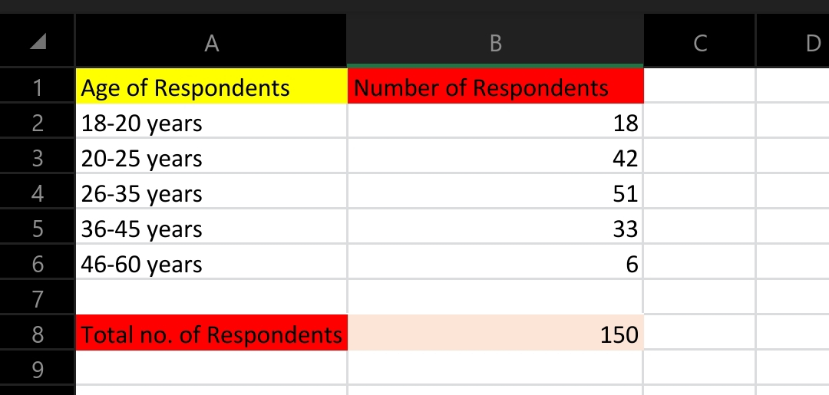

Figure 1 Age of Respondents (Statistical Data)

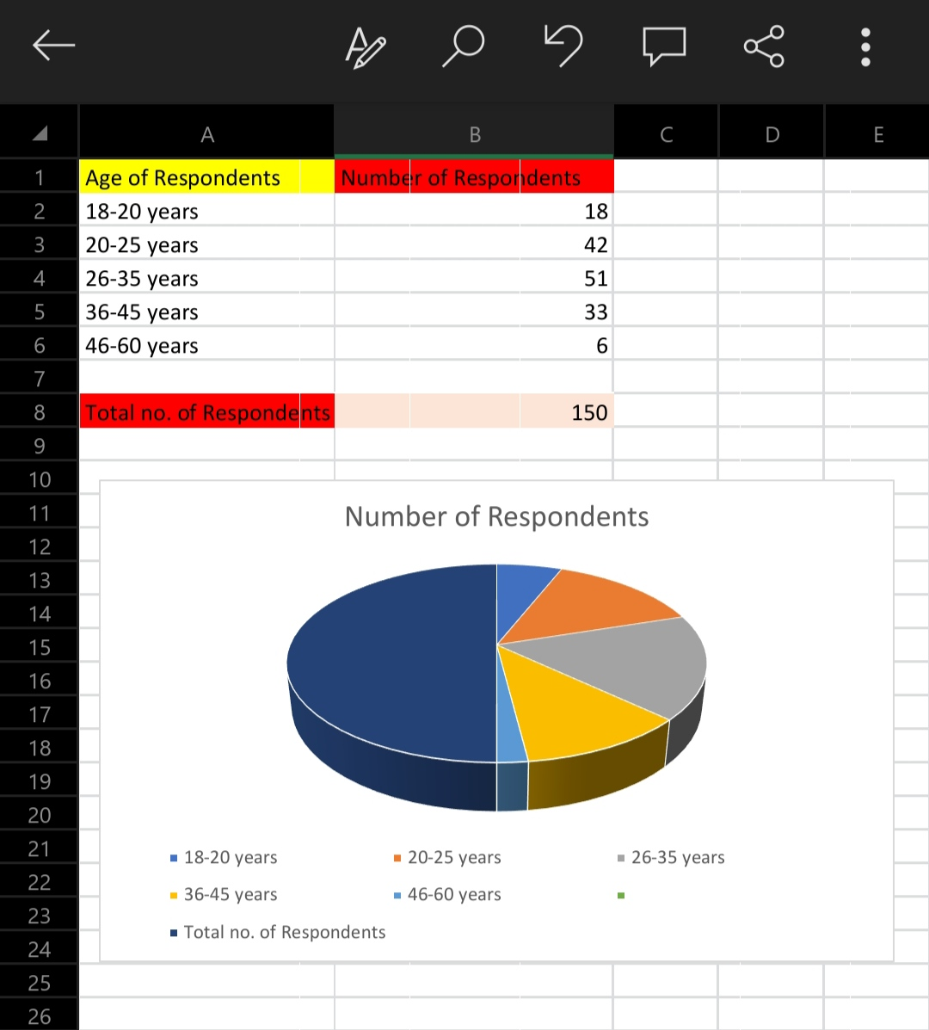

Figure 2 Age of Respondents (Pie Chart)

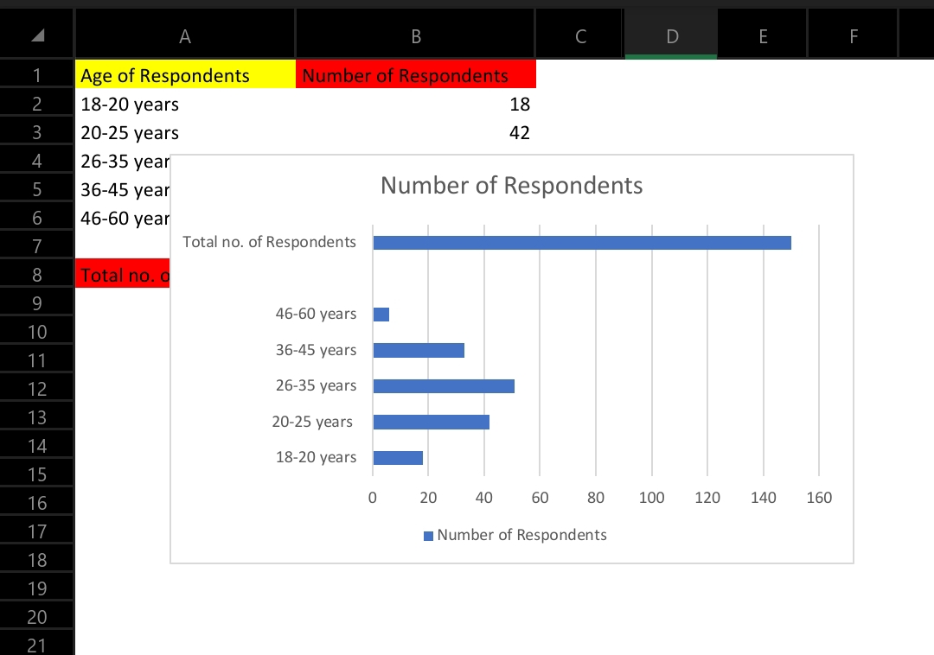

Figure 3 Age of Respondents (Horizontal Bar Graph)

Age Distribution of Respondents

The respondents were asked why they were at Wamasaa Bus Terminal that day, whether to buy a bus ticket, wait for a bus, or wait for a passenger. 44% of the passengers are gathered at Wamasaa Bus Terminal to purchase bus tickets, with 48% waiting to board a bus and 8% waiting for a passenger.

The second question asked of the respondents was if they had previously purchased an over-the-counter bus ticket, and the answer was that all respondents had done so. 98%, or 147 out of 150 respondents, said it will take between 30 minutes and more than an hour to buy a bus ticket using this approach (this is a time fame between leaving the house to purchasing a bus ticket). This time can be greatly reduced if a collaborative mechanism for purchasing a bus ticket is devised.

The responders are then asked to rank the state of Wamasaa Bus Terminal on a scale of very good to very terrible. The percentages received from the responses are shown in Table 3.1.

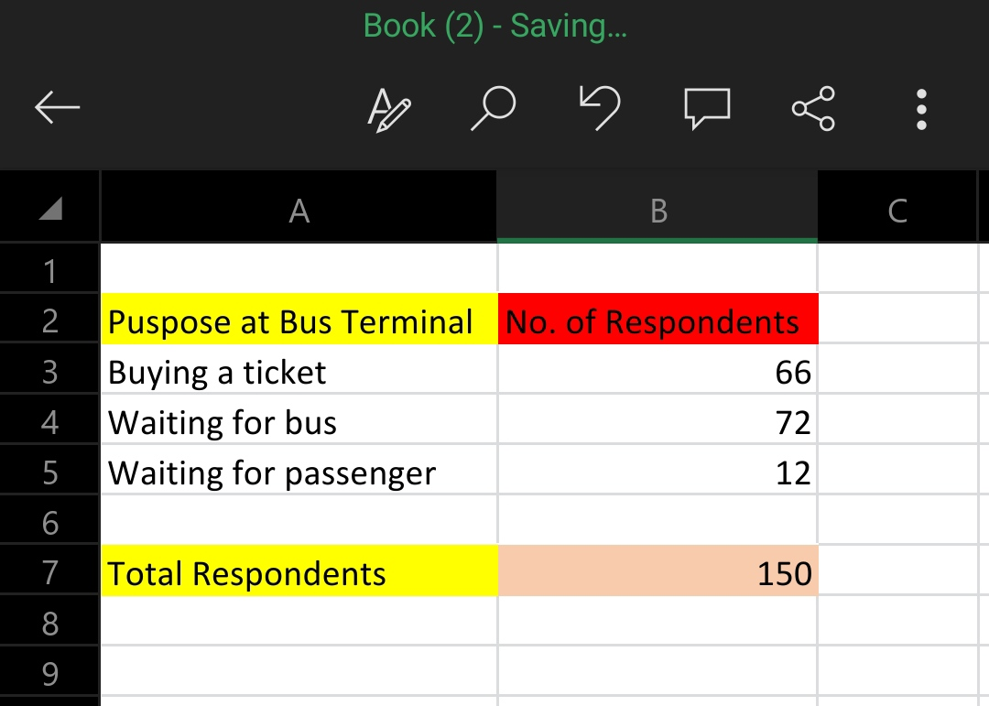

Figure 4 Purpose at Bus Terminus (Statistical Data)

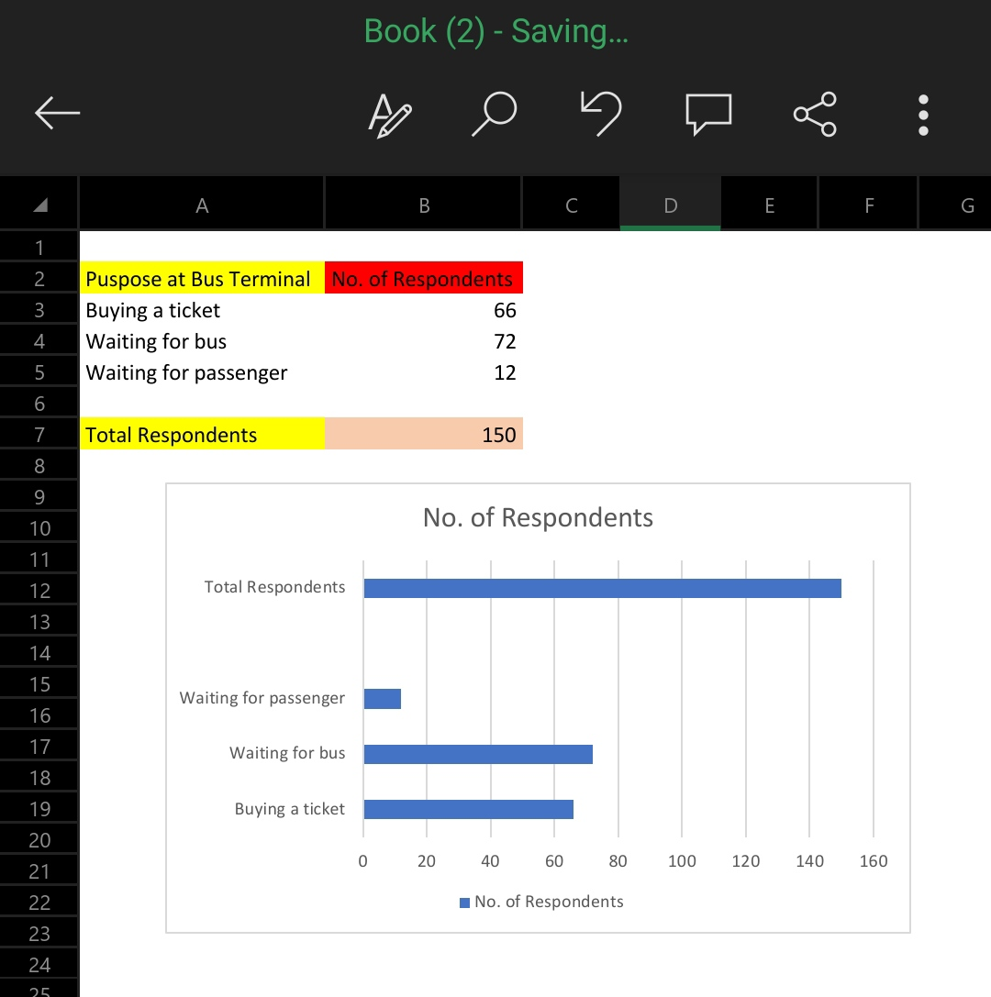

Figure 5 Purpose at Bus Terminus (Horizontal Bar Graph)

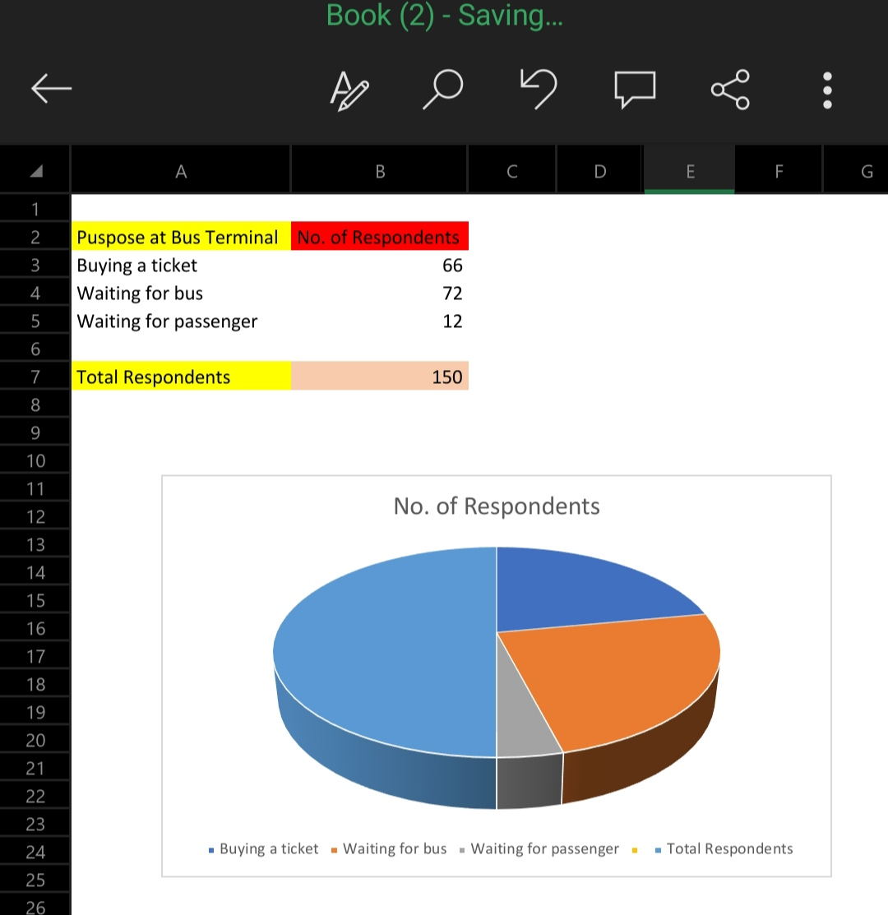

Figure 6 Purpose at Bus Terminus (Pie Chart)

None of the respondents rated the conditions at Wamasaa Bus Terminal as very good, good, or average. All of the responders chose terrible and extremely bad for the state of the Wamasaa Bus Terminal. This could be because Nairobi's conditions are deteriorating due to both human and transportation congestion. The condition of Wamasaa Bus Terminal can be improved if an Online Bus Ticketing System software is developed to alleviate congestion at Wamasaa Bus Terminal.

The majority of respondents have Internet connection at home or at work. There are 16%, or 24 out of 150, who say they do not have Internet connection, while 84%, or 126, say they do. Out of the 126 respondents that have Internet connection, more than two hours per week are spent surfing the web. 4% of respondents, or 5 people, surf 2 to 4 hours per week, 26%, or 33 people, surf 5 to 6 hours per week, and 70%, or 88 people, surf more than 6 hours per week. The majority of respondents use the Internet for email and to look for specific information. The age groups that use computers or the Internet the most are those aged 20 to 45. This group uses the Internet for email, general information retrieval, and information search. The remainder of those polled use the Internet for shopping, banking, and other purposes. The vast majority of respondents chose email, general information retrieval, and Internet search for specific information.

The next question asks if respondents have ever made an online payment via the Internet. Figure 3.3 reveals that 9.5% of respondents have previously made an online payment and 90.5% have never made an online payment over the Internet.

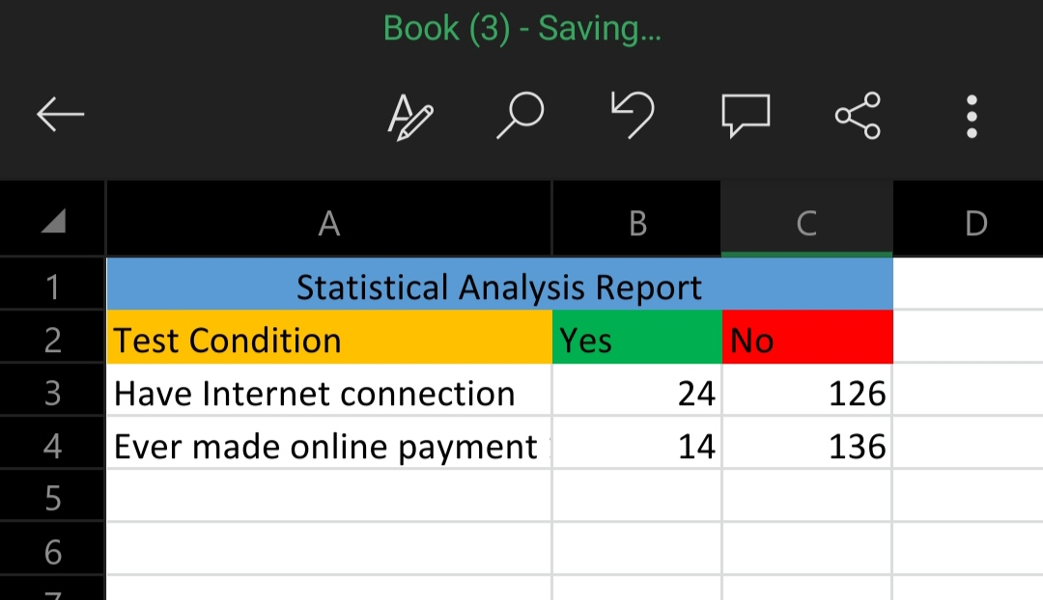

Figure 7 Analysis Report (Statistical Data)

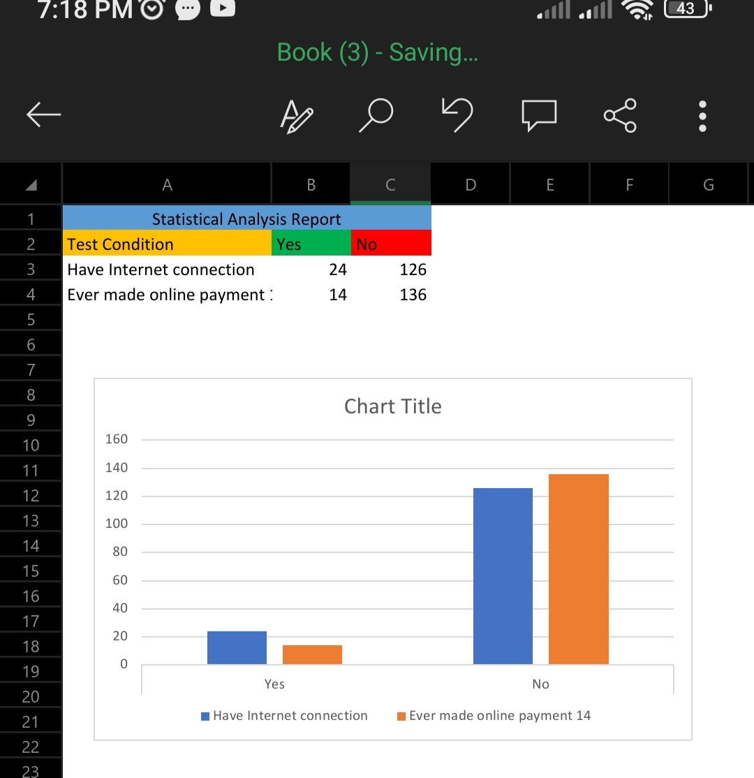

Figure 8 Analysis Report (Horizontal Bar Graph)

The next question concerns respondents' knowledge of the existing bus e-ticketing system provided by a few bus operators in Nairobi. Out of the 87 respondents who had heard of the bus e-ticketing system, 67 (44.8%) are aware of the existing bus e-ticketing system supplied by Nairobi bus operators, and only 35 (23%) have used this bus e-ticketing system to purchase a bus ticket. The remaining respondents have heard of bus e-ticketing systems but have not purchased an online bus ticket before citing factors that limit trust in online bus ticketing systems such as a lack of information, being unfriendly, having slow page downloads, a lack of security, and a lack of understanding of e-commerce.

On the other hand, 83 respondents (55.2%) are unaware that bus operators in Nairobi offer an e-ticketing system. According to this, the government and bus operators could advertise more or utilize other media to educate the public on the benefits of bus e-ticketing systems. This will then be used to promote and encourage the general public to use the Online Bus Ticketing Systems.

The 35 respondents who had purchased a bus ticket using the existing bus e-ticketing system were then asked to rate the system; please see Table 3.2 for the responses.

This question was designed to elicit information on existing bus e-ticketing systems from respondents. The question was evaluated using criteria such as services, reliable information, whether the existing bus e-ticketing system services are user-friendly, cost-effective, and convenient payment methods, and whether the web sites were informative.

Effectiveness of Online Bus Ticketing System

With regard to the above-mentioned issue, all 35 respondents agree that existing bus e-ticketing is more efficient than buying a bus ticket at the counter, in terms of cost, time, and convenience. Surprisingly, all respondents believe that the current bus e-ticketing system is untrustworthy. An Online Bus Ticketing System must be dependable in terms of data identification. Identification is required for communication between computers and computer systems. An Online Bus Ticketing System should be dependable by supplying clients with up-to-date information. As a result, more clients will be encouraged to use the services. Only 23 of the 35 respondents believe the current bus e-ticketing system is user-friendly and informative. The services offered by an Online Bus Ticketing System must be user-friendly in order to meet the public's request and response. It is stated that in order to accomplish the effectiveness of the Online Bus Ticketing System, all bus operators' services must be more effective across conventional borders and interact with other bus operators, stakeholders, and their customers.

In this sense, informed means offering all necessary information in an easy-to-use and interactive way. To elaborate, useful information is information that is written and depicted in such a way that it encourages the viewer to see and learn more about the information in the application. Simultaneously, the application must be simple to use, with pleasant contact between the consumer and the bus operator administrator. Readability is an informational component. This means that the text and graphics used in the program must be legible. The potential of online bus ticketing systems is enormous because services may be supplied seven days a week and around the clock. In short, it is the next revolution in bus ticketing in Nairobi and throughout Kenya, as these functionalities allow for a stronger contact between the user and the operators. Online Bus Ticketing System is defined as offering information on services as well as the ability to make bus ticketing transactions via the Internet, and it is also more cost effective than traditional methods of collecting information.

The following section of the questionnaire focuses on the respondents' ideas for the future of the Online Bus Ticketing System. The inquiry is if the respondent always travels by bus with the same company. This question is aimed at respondents who have never heard of the Online Bus Ticketing System (63 respondents), respondents who are unaware of the existing online bus ticketing supplied by Nairobi bus operators (67 respondents), and respondents who have used the existing online bus ticketing (35 respondent). Out of these 165 respondents, 129 claim they do not use only one bus operator for their travel needs. The remaining 36 respondents said they use the same bus operator because the bus operator has an Online Bus Ticketing System, 9 said there is only one bus operator to their location, and another 9 said it is difficult to seek for tickets from other bus operators.

Reasons for using services from 1 type of bus operator

This chapter concludes that the general public and bus operators are ready to move forward with the use of an Online Bus Ticketing System application. It is not enough to just implement efficient online sales and purchase of bus tickets; other critical concerns connected to Decision Support System and Management Information System that will benefit both customers and bus operators must also be considered. The Decision Support System will be able to retrieve bus information based on the user's preferences, such as bus route destination. The Management Information System can generate a variety of reports for the benefit of bus operators. When purchasing an online bus ticket, the system should provide appropriate security and confidence to the public, so that the layperson is comfortable using the Online Bus Ticketing System application. Concerning the issues of cost effectiveness, dependability, and people-orientedness, the public should use or employ the services and provide input to bus operators on future improvements.

However, severe concerns exist, such as poor living conditions in Nairobi, a lack of self-security, traffic congestion, the inability to purchase bus tickets, and a lack of travel/transport information. According to the study findings, the respondents identified the difficulties listed above as the source of their reluctance to purchase a bus ticket in Nairobi.

Other concerns that must be addressed include customer training, education, and encouraging and motivating customers to use the Online Bus Ticketing System web portal once it is established.

Finally, the system must be capable of acting as a check and balance between bus operators and the general public. This is possible by combining a Decision Support System and a Management Information System into the system. The operator must provide the best service to the customer based on their preferences, and if the customer is satisfied (the customer's objective is met), the bus operator can be assured of repeat customers (the bus operator's objective is met), and the reaction is otherwise if the service falls short of the customer's expectations, and the cycle continues.

## 3.5 DATA AND SYSTEM ANALYSIS

This analysis was conducted during the gathering phase for the purpose of making changes to improve current effectiveness, efficiency and capability, as well as correcting flaws that may have existed.

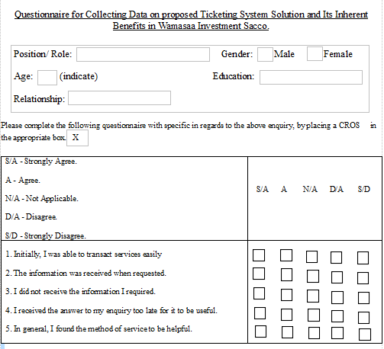

Figure 9: Questionnaire Template

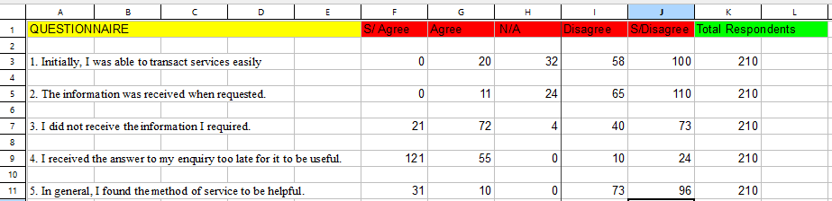

Figure10: Questionnaire Statistical Data

## 3.6 SYSTEM SPECIFICATION

Technology in the information era has finally been put to good use. The widespread adoption of IT has prompted many businesses to adopt new methods of streamlining their operations. Information technology (IT) is used by businesses to disseminate data to target audiences.

Modern information consumers like to obtain their news entirely online, without ever having to crack open a book or magazine. There are still many providers of bus ticket booking services that have not embraced IT, as evidenced by a number of case studies; this, combined with the fact that there are currently very few media outlets offering an online bus ticket booking service, will undoubtedly increase the level of difficulty users experience when attempting to book tickets.

This study uncovers the potential for IT application in the service provider-end-user relationship; one such service provider is the Sacco bus business, which offers an online bus ticket booking system. The OOAD user-system relationship forms the basis for the approach taken when purchasing tickets online (Object Oriented Analysis Design).

The study's overarching objective is predicated on the belief that passengers will be better able to put the information technology (IT) at their disposal thanks to the availability of online bus ticket reservation. Information Technology; Reservation; Online Ordering and Acceptance of Deliveries; Convenience of Ordering.

## 3.7 HOW THE SYSTEM WORKS

The system engages to login dialogue box when prompted to open by the user. The user keys in their personal credentials to access the system.

The primary menu of the tickets management system will load when the program is launched. The options available in the primary menu vary depending on whether the user accesses the system as an Administrator or a customer.

Initiating the ticketing process begins when a passenger or customer decides to book transportation by clicking Book now and selecting the designated route and timeline as well as providing their basic user information such as name and keying them as input to the system for it to generate the intended ticket output.

This data is necessary for bus ticket validation and passenger identification. When the passenger pays the fare, the ticket is processed and printed out while if the ticket is not paid for, its activity status remains as unpaid and not until payment is complete does further ticket processing occur.

All these tasks and processes are overseen by an Administrator. The administrator is privileged to keep track of the passengers and the bookings through the system management tools. This makes it easy for auditors to evaluate data through the computer to verify on report compliance.

The Administrator in the system is able to access functions such as Add Bus. In this portion of the program, the administrator can add a bus and enter facts such as its registration number of the bus and capacity or the number of passengers it can hold. In addition, the Administrator has access to the Add seat option. This area allows you to add or delete seat numbers of a certain bus. When a seat is created or added, it becomes accessible during the reservation process. The ticket conveniently includes a record of the passenger's assigned seat number. There is also a screen alert you can look at to see if there are any open seats.

The customers accessing the system get to find the destinations they would wish to head to and the time these travels are offered. They also get to see if their ticket booking process has been successful on reception of a reference number so that they can advance to making payment.

## 3.8 LOGICAL AND PHYSICAL DESIGN

**Logical Design**

This is an abstract representation of the data flow, inputs, and outputs of the system. This design arranges data into a series of logical relationships between the entities and attributes involved.

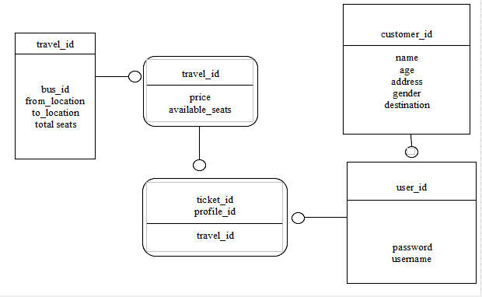

Figure 11: Logical Design

This design shows how different variables in each class communicate with one another to provide the online ticketing service to the customers through the clients of the organization.

**Physical Design**

This design involves the process of determining the data storage organization and data access characteristics of the database in order to ensure its integrity, security, and performance.

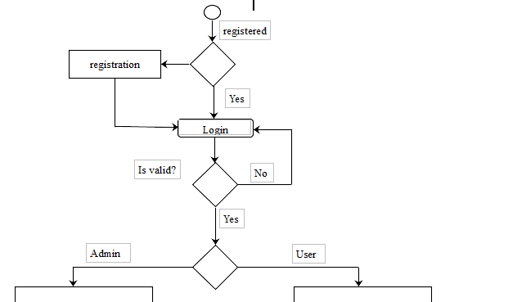

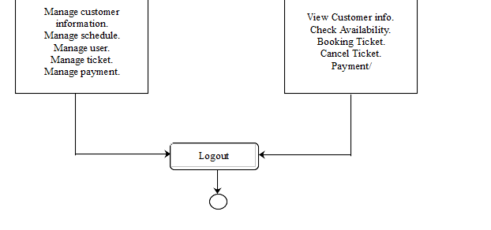

Figure 12: Physical Design

## 3.9 SYSTEM ARCHITECTURE

This architecture shows user interaction with the database server to access ticketing services through the system. Different services are accessible depending on the heirarchy of the organizational structure.

This Ticketing Management System takes up a microservices architecture pattern which upholds the N-tier Architecture with three different layers: Presentation (what user sees in the browser), Application (holds the business logic), Data layers (holds the data).

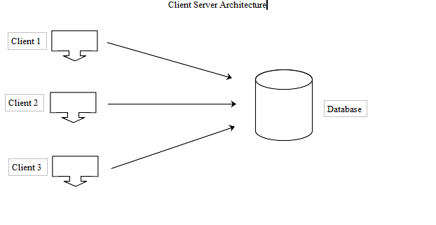

Figure 13: Client-Server Architecture

This Client Server based architecture gives an illustration of how the clients access services of the e-ticketing system provided by the database server. However, only the Administrator has access to the server to make different changes or fix issues related with the system.

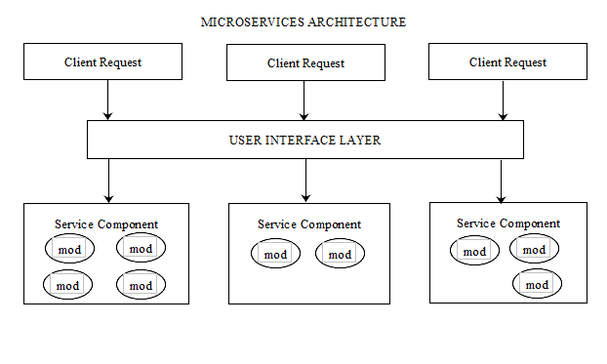

Figure 14: Microservices Architecture

This Microservices Architecture gives a further representation of the system. The client accesses the system and makes a request depending on what task they would want to be executed. Through the User Interface layer, the request is handed to the respective service component to access the modules within the service components to resolve the request given to it.

## 3.10 OBJECT ORIENTED DESIGN

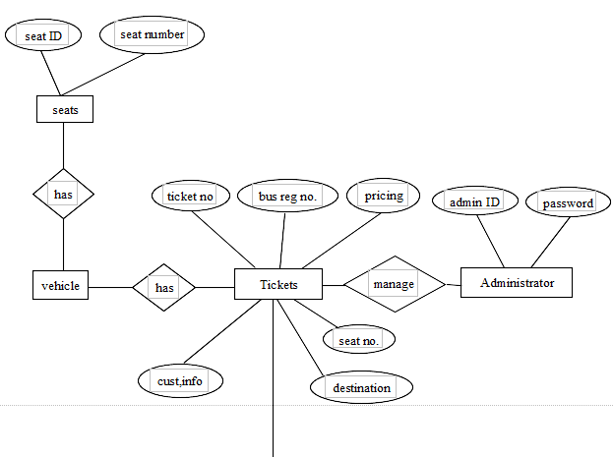

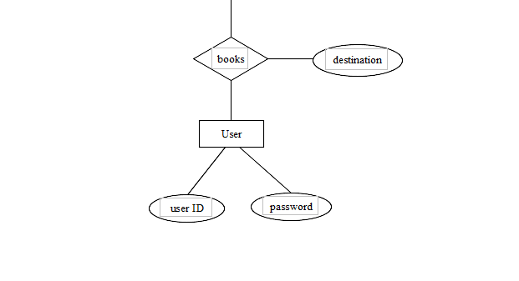

Figure 15: Object Oriented Design

This is an ER model (Entity Relationship) diagram. It illustrates how the different entities of the system along with their attributes have a relationship tofunction together within the system.

## 3.12 SUGGESTED MINIMUM REQUIREMENTS

**Functional Requirements**

Functional requirements define the specific functions that the system performs, along with the data operated on by the functions. The functional requirements are presented in scenarios that depict an operational system from the perspective of its end users. Included are one or more examples of all system features and an enumeration of all the specific requirements associated with these features.

• The system shall incorporate mechanism to authenticate its users.

• The system shall verify and validate all user input and should notify in case of error detection and should help the user in error correction.

• The system shall allow sharing of files in the system.

• The system shall allow quick messages to be exchanged without face-to-face interaction.

**Non-Functional Requirements**

Non-functional requirements address aspects of the system other than the specific functions it performs. These aspects include system performance, costs, and such general system characteristics as reliability, security, and portability. The non-functional requirements also address aspects of the system development process and operational personnel. It includes the following:

• The system shall be user friendly and consistent.

• The system shall provide attractive graphical interface for the user.

• The system shall allow developer access to installed environment.

• The system shall target customer base.

**3.13 OTHER DIAGRAMS**

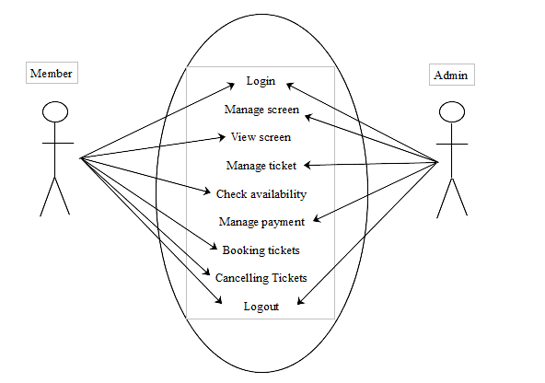

Figure 16: User Diagram

Above is a Use Case diagram that shows what features are accessible to different users with different privileges in the system.

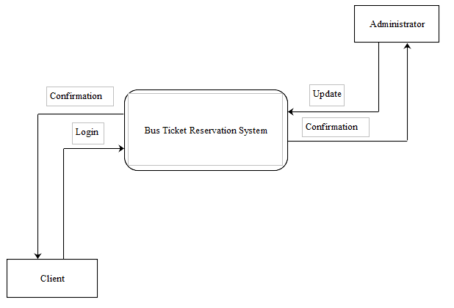

Figure 17: Data Flow Diagram

This is a simple DFD (Data Flow Diagram) that shows how data dlows in the system from the point of logging in to the point of logout. It also illustrates how data flows between the Client and the Administrator through the Ticketing System.

## 3.14 DESIGN PHASE REPORT CONTENTS

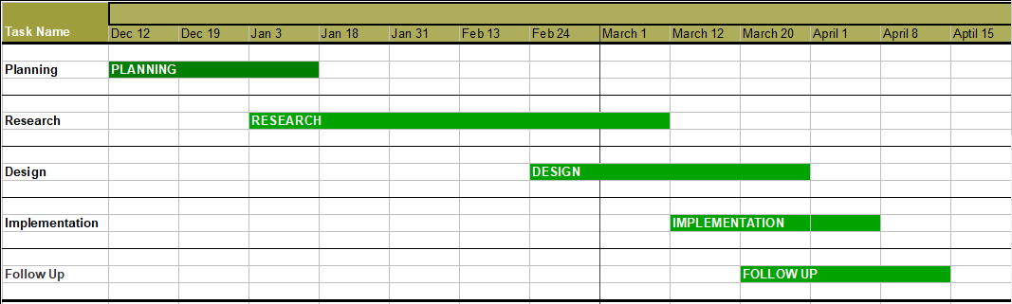

# CHAPTER 4

## 4.1 INTRODUCTION

This chapter provides a summary of the processes undertaken to generate the system code for the generated system. Additionally, it provides screenshots of the functioning system as well as providing information about the various testing methods the system underwent.

Some code snippet of the system is provided at the end of the document. However, this chapter will also provide the limitations of the system. The different tests subjected to the system are also discussed in detail. The conclusion of the project is also highlighted stating if the client's issues were resolved and to what extent

## 4.2 SYSTEM CODE GENERATION

The system code for this projected is generated through the object-oriented programming paradigm. This is to allow capturing of real-world entities with their behaviors defined. It is flexible enough and solves real world existing problems.

## 4.3 TESTING

The ticketing system developed was subjected to set of valid inputs to validate the outputs of the system against premeditated set of outputs.

Before software is supplied to our customers, the products are subjected to extensive tests in accordance with the latest standards. Software development includes all necessary software tests, elaboration of updated test strategies and application of automatized test tools.

After a problem has been solved, the cause of the malfunction, the type of malfunction remedy and the time required are documented. Over time, a knowledge database has been created to support efficient work. Recorded messages can be reported at all times.

To accomplish this, the ticketing system developed was subjected to set of valid inputs to validate the outputs of the system against premeditated set of outputs.

Smoke testing is used to verify that basic and critical functionality of the system under test is working fine at a very high level.

To run an effective usability test, you need to develop a solid test plan, recruit participants, and then analyze and report your findings.

|  |  |  |  |  |
| --- | --- | --- | --- | --- |
| **TEST SCENARIO** | **TEST CASE** | **TEST** **STEPS** | **TEST DATA** | **VALIDITY** |
| **Check Login Functionality** | Check response on entering valid username and password. | Launch Application.  Enter username.  Enter password.  Click OK. | Username.  Password. | Login Successful. |

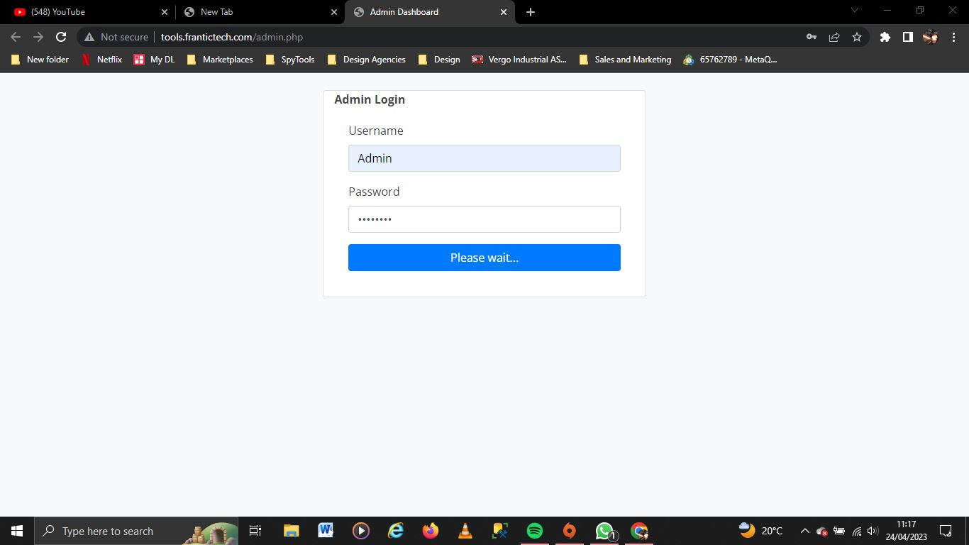

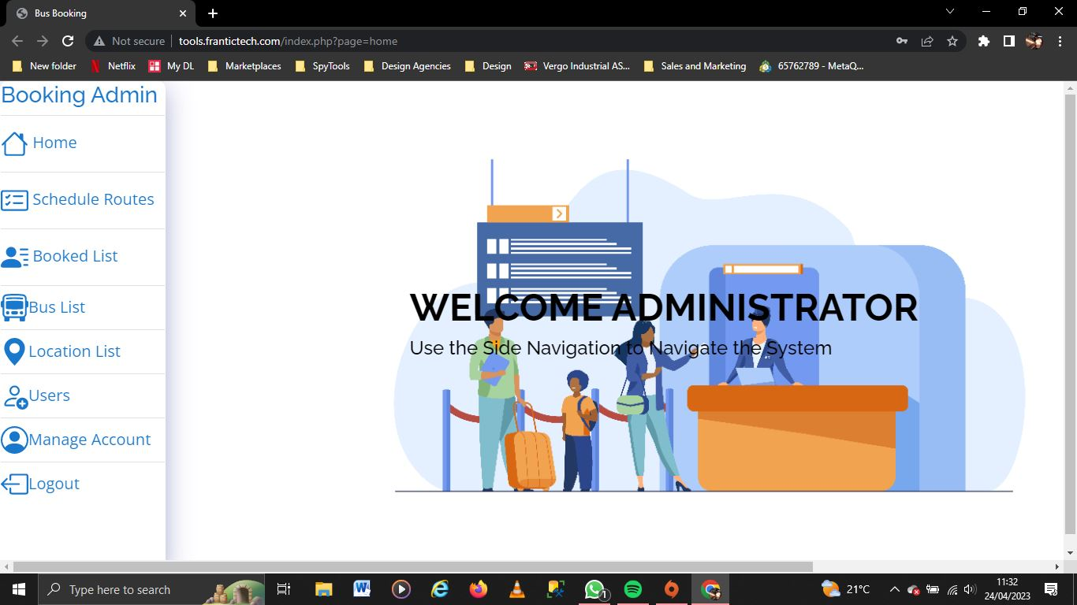

|  |  |  |  |  |
| --- | --- | --- | --- | --- |
| **TEST SCENARIO** | **TEST CASE** | **TEST** **STEPS** | **TEST DATA** | **VALIDITY** |
| **Check Book Ticket Functionality** | Check on ticket booking process on finding designated location of travel, submitting customer detail such as name, number of seats booked and confirmation of payment. | Launch the system on Google Chrome.  Click on the Book button feature.  Find schedule by adding destination and arrival location and date.  Click Book now after finding the schedule.  Insert name and seats booked to the book details.  Click book. | Destination location.  Arrival location.  Date for travel  Customer name.  Number of seats to book. | Reception of reference number to confirm successful booking. |

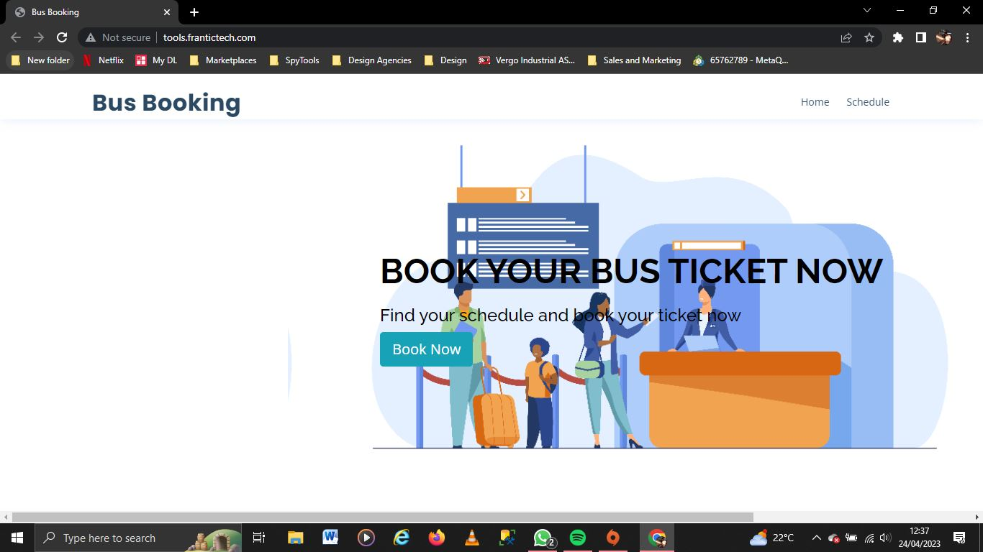

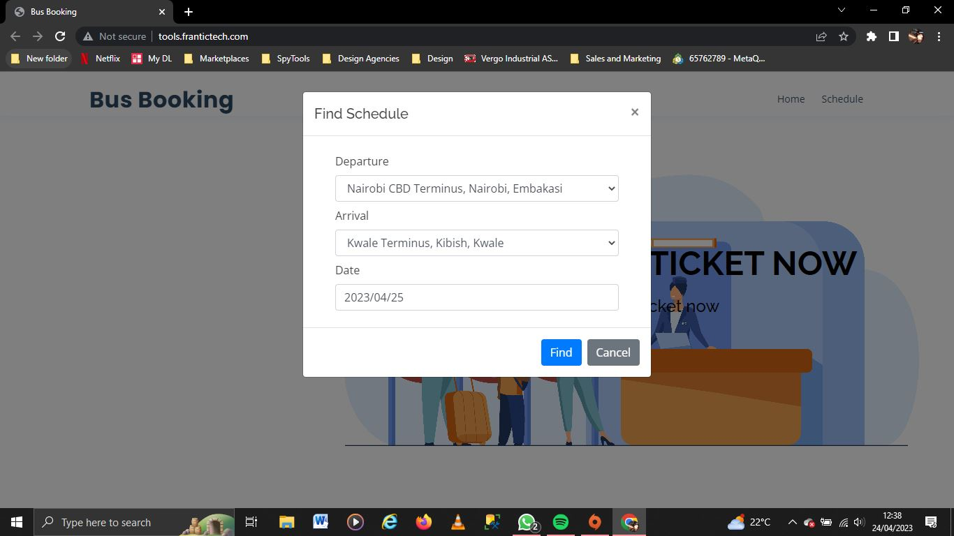

|  |  |  |  |  |
| --- | --- | --- | --- | --- |
| **TEST SCENARIO** | **TEST CASE** | **TEST** **STEPS** | **TEST DATA** | **VALIDITY** |
| **Check Add User Functionality** | Check on adding user(s) to the system as an Administrator. | Launch the system on Google chrome or preferred browser.  Click on Users on the left panel.  Click Add new.  Input the name of the user, give a preferred username and set password for the account.  Click Save. | Name.  Username.  Password. | New added user shows in the table containing user data.  Adding User successful. |

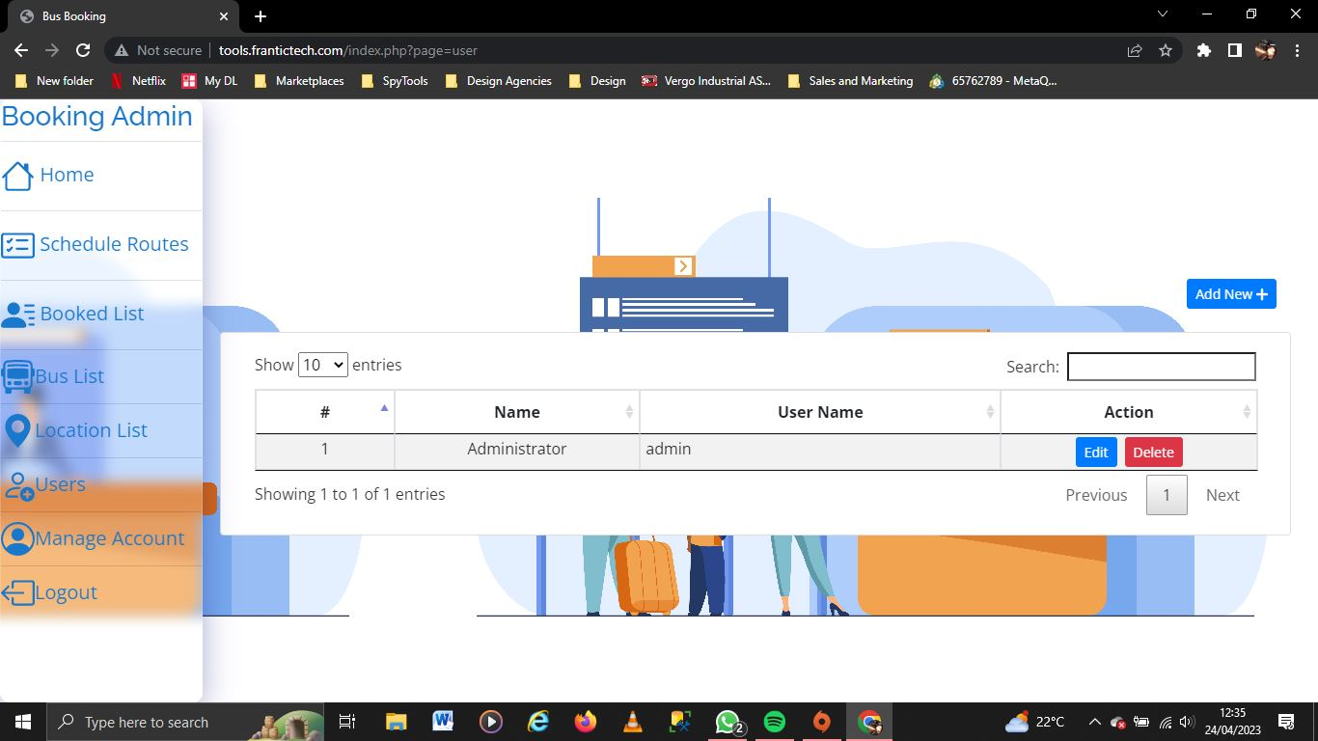

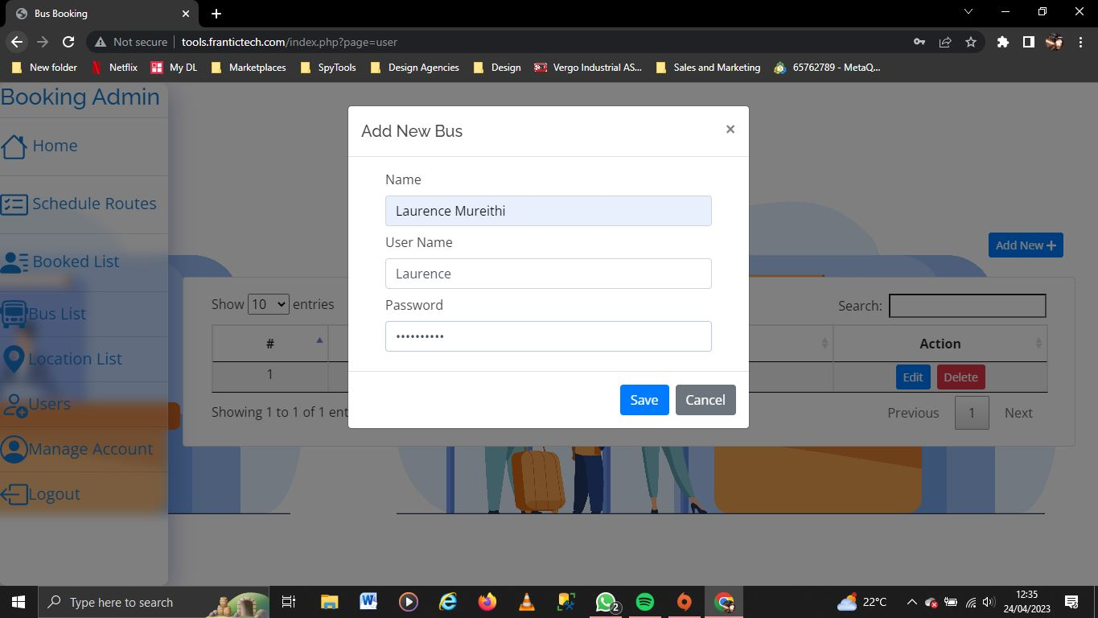

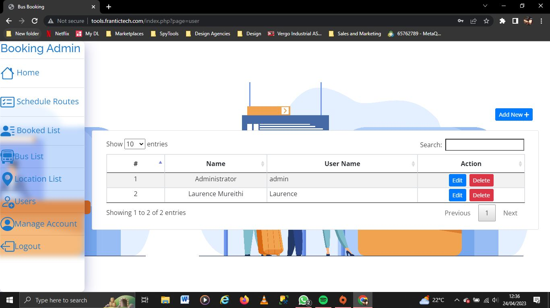

|  |  |  |  |  |
| --- | --- | --- | --- | --- |
| **TEST SCENARIO** | **TEST CASE** | **TEST** **STEPS** | **TEST DATA** | **VALIDITY** |
| **Check Add Bus Functionality** | Check on adding buses for booking availability. | Launch and login to the system as Administrator.  Click on the Bus List feature on the left panel.  Click Add New option.  Enter bus registration number as name and amount of availability.  Click Save. | Bus registration number.  Bus number. | New added bus appears on the Bus List.  Add bus successful. |

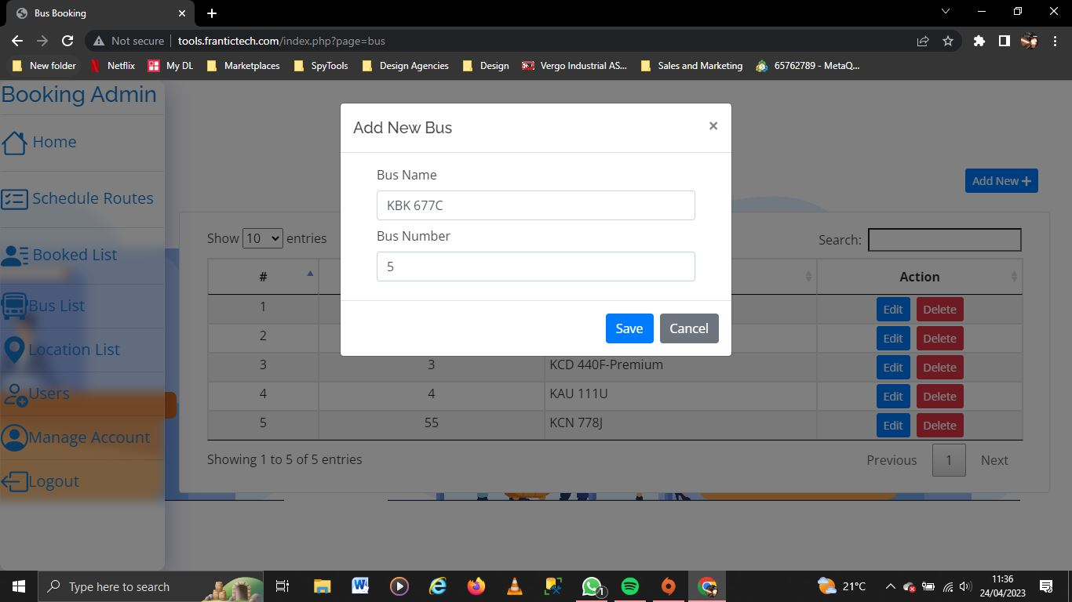

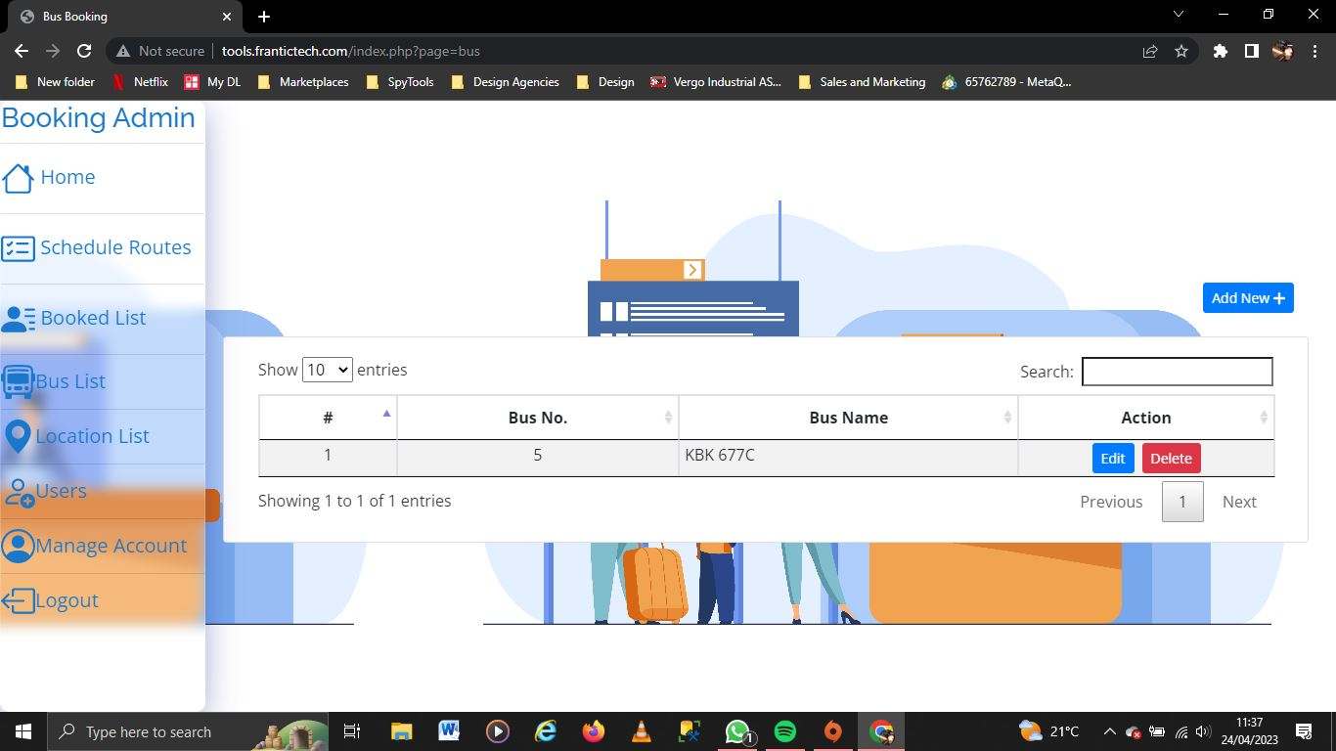

|  |  |  |  |  |
| --- | --- | --- | --- | --- |
| **TEST SCENARIO** | **TEST CASE** | **TEST** **STEPS** | **TEST DATA** | **VALIDITY** |
| **Schedule Routes and Add Seats.** | Check on Route Scheduling and Seat Addition. | Launch and login to the system as Administrator.  Click Schedule Route feature on the left panel.  Click Add New.  Select bus, to and from location from the dropdowns in the dialogue boxes.  Enter departure and arrival time.  Add available seats and price per seat.  Click Savw. | Bus Registration name.  To and from locations.  Departure time and estimated time of arrival.  Available seats.  Price per seat. | New route shows up in the schedule route table.  Route scheduling and seat addition successful. |

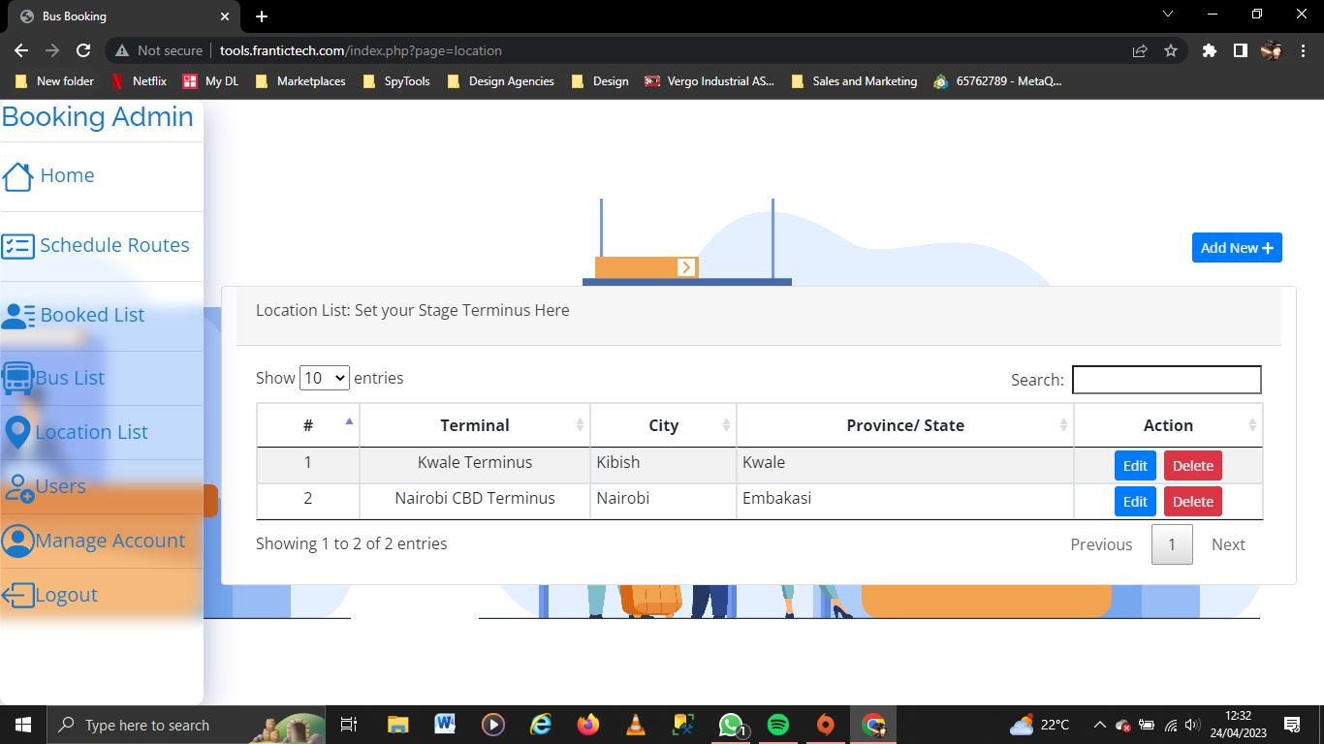

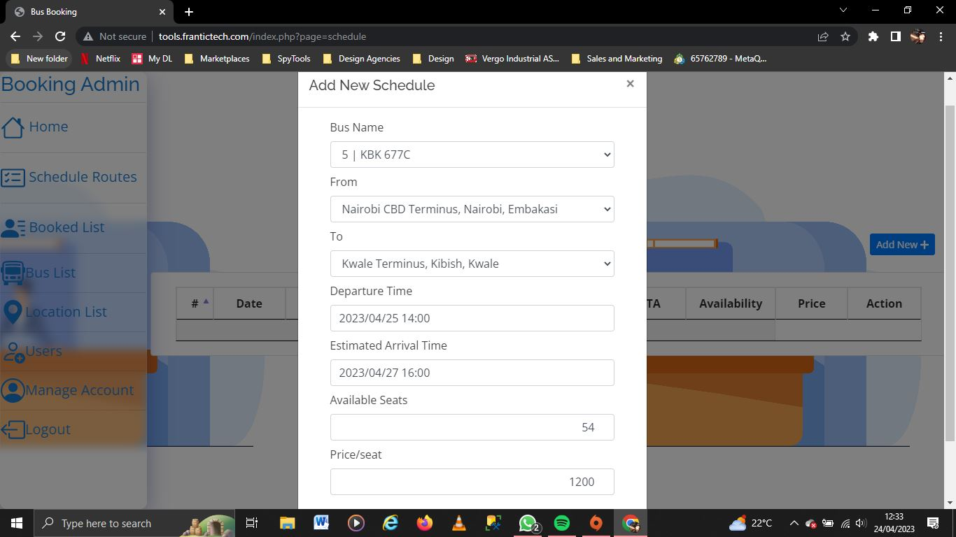

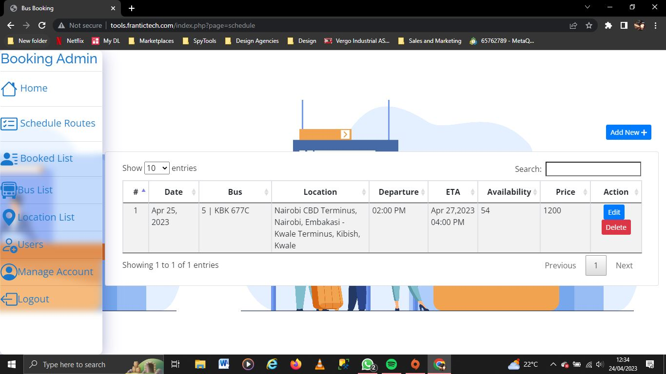

|  |  |  |  |  |
| --- | --- | --- | --- | --- |
| **TEST SCENARIO** | **TEST CASE** | **TEST** **STEPS** | **TEST DATA** | **VALIDITY** |
| **Check Add Location Functionality** | Check and set location to and from destinations. | Launch and login to the system as Admin.  Click Location List feature on the main menu.  Click on Add new.  Enter terminal name, city and province for to and from locations.  Click Save. | Terminal name.  To and from destination. | New added location shows up in the Location table.  Add location successful. |

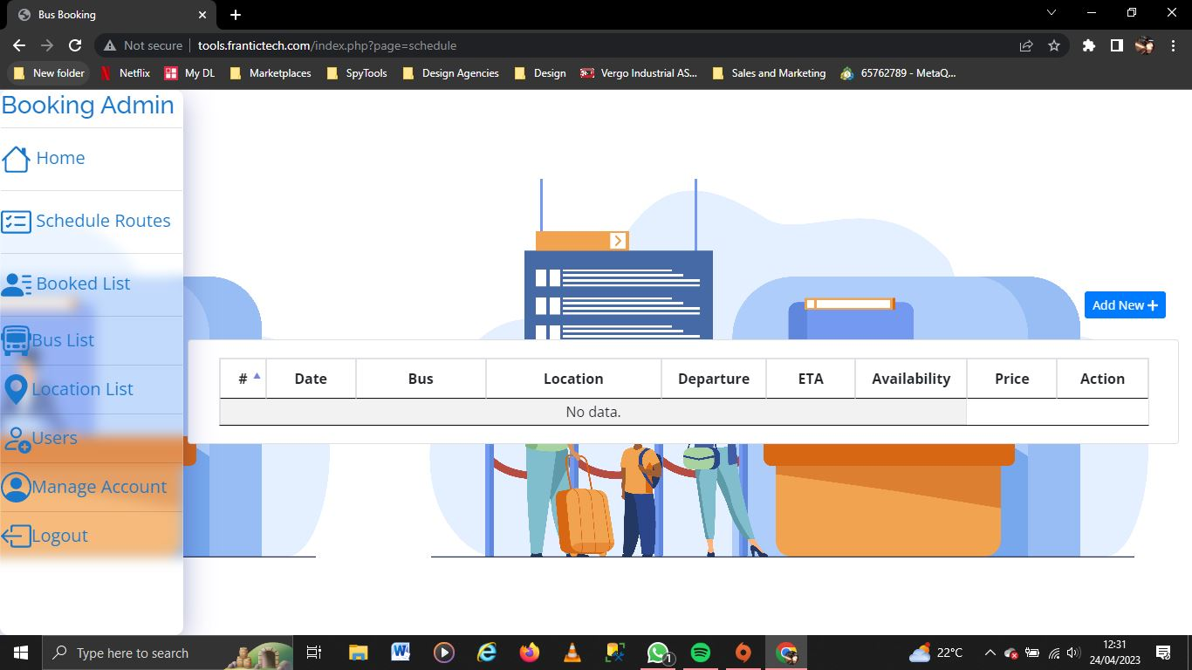

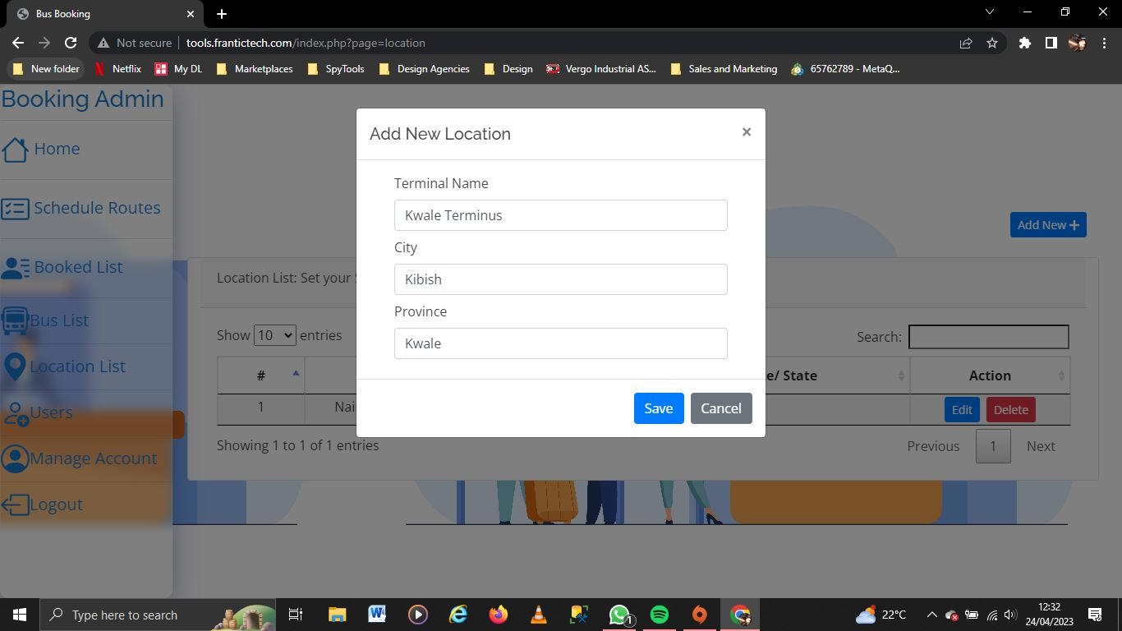



|  |  |  |  |  |
| --- | --- | --- | --- | --- |
| **TEST SCENARIO** | **TEST CASE** | **TEST** **STEPS** | **TEST DATA** | **VALIDITY** |
| **Check Logout Functionality** | Check response on logging out. | Click logout feature in the main menu. | N/A | Logout successful. |



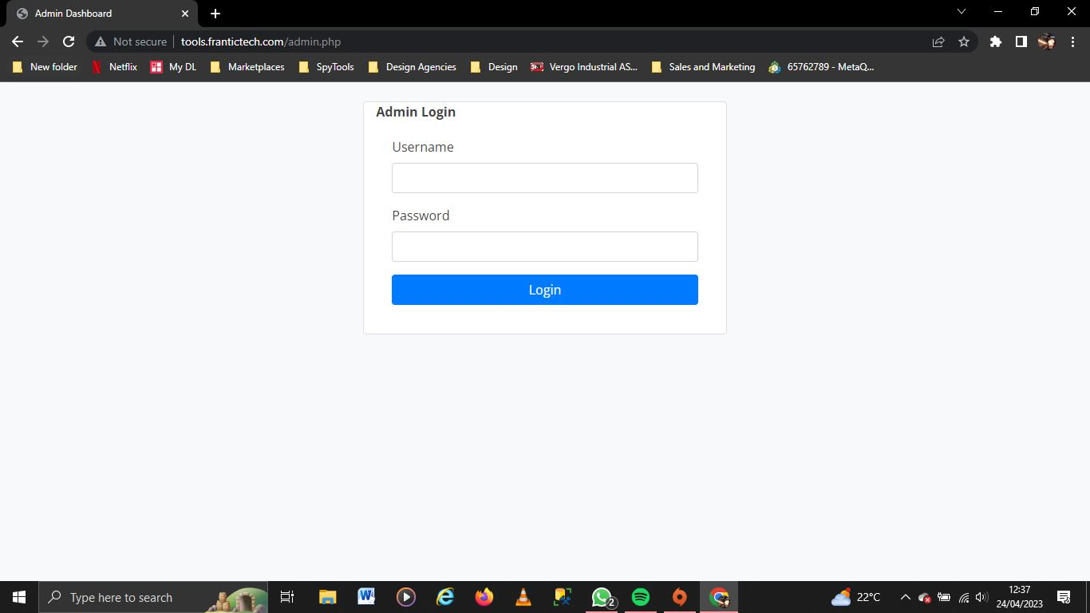STRESS TEST

|  |  |  |  |  |
| --- | --- | --- | --- | --- |
| **TEST SCENARIO** | **TEST CASE** | **TEST** **STEPS** | **TEST DATA** | **VALIDITY** |
| **Check Login stress test.** | Check response on llogging in with invalid credentials. | Enter invalid user credentials in the dialogue boxes.  Click Login | Invalid Username and Password. | Incorrect username or password.  Login unsuccessful. |

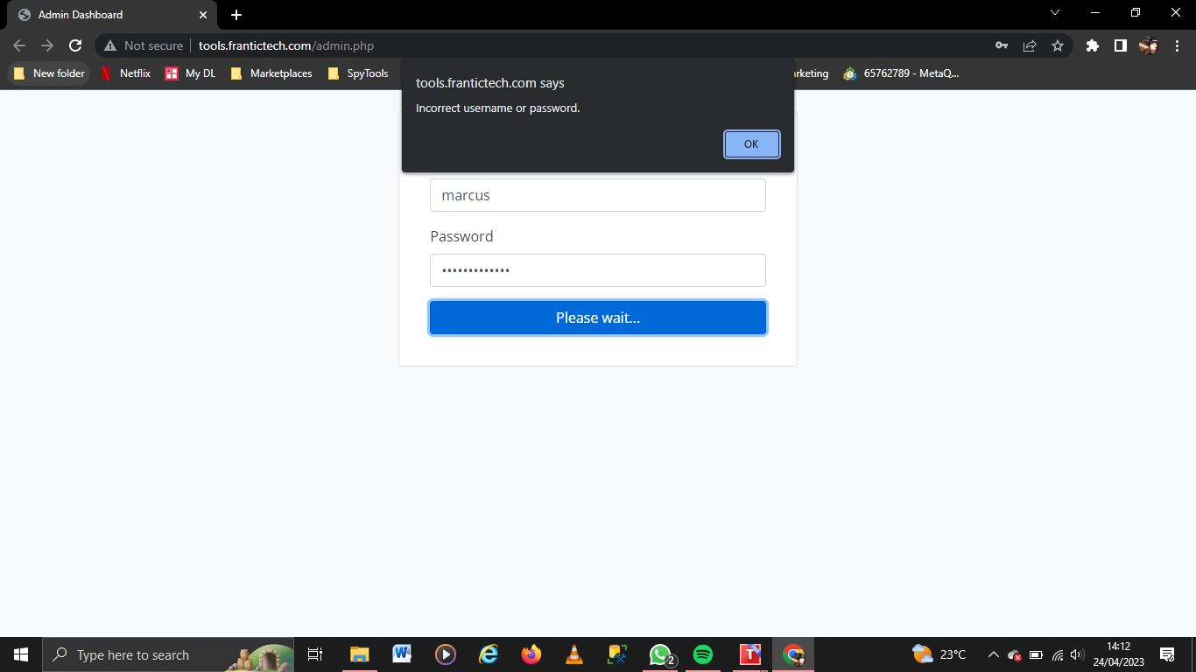

|  |  |  |  |  |
| --- | --- | --- | --- | --- |
| **TEST SCENARIO** | **TEST CASE** | **TEST** **STEPS** | **TEST DATA** | **VALIDITY** |
| **Check Book Ticket Functionality** | Check if system makes booking and ticket purchase | Login then Search and Find route of interest.  Click on Book Now.  Enter name and number of seats you wish to book.  Search for your booked ticket under My Tickets and click on make payment from the mpesa prompt.  Click Download Ticket. | Departure location.  Arrival location.  Date to book.  Amount of payment.  Phone number. | Book Ticket successful. |

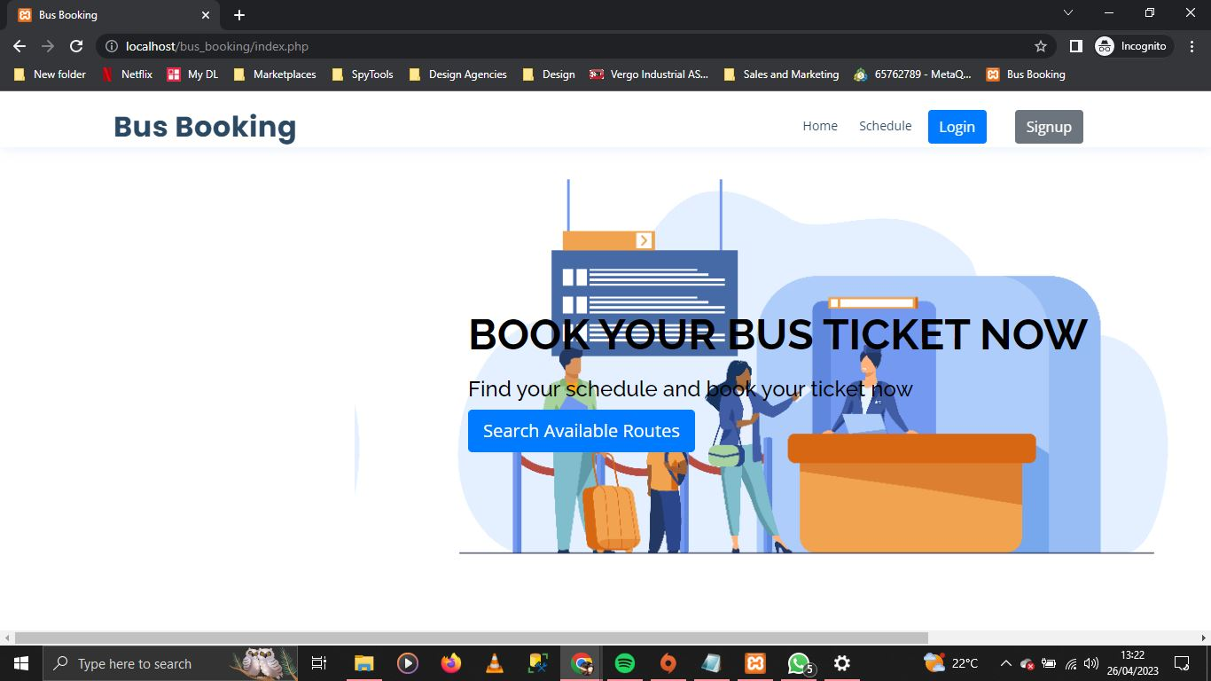

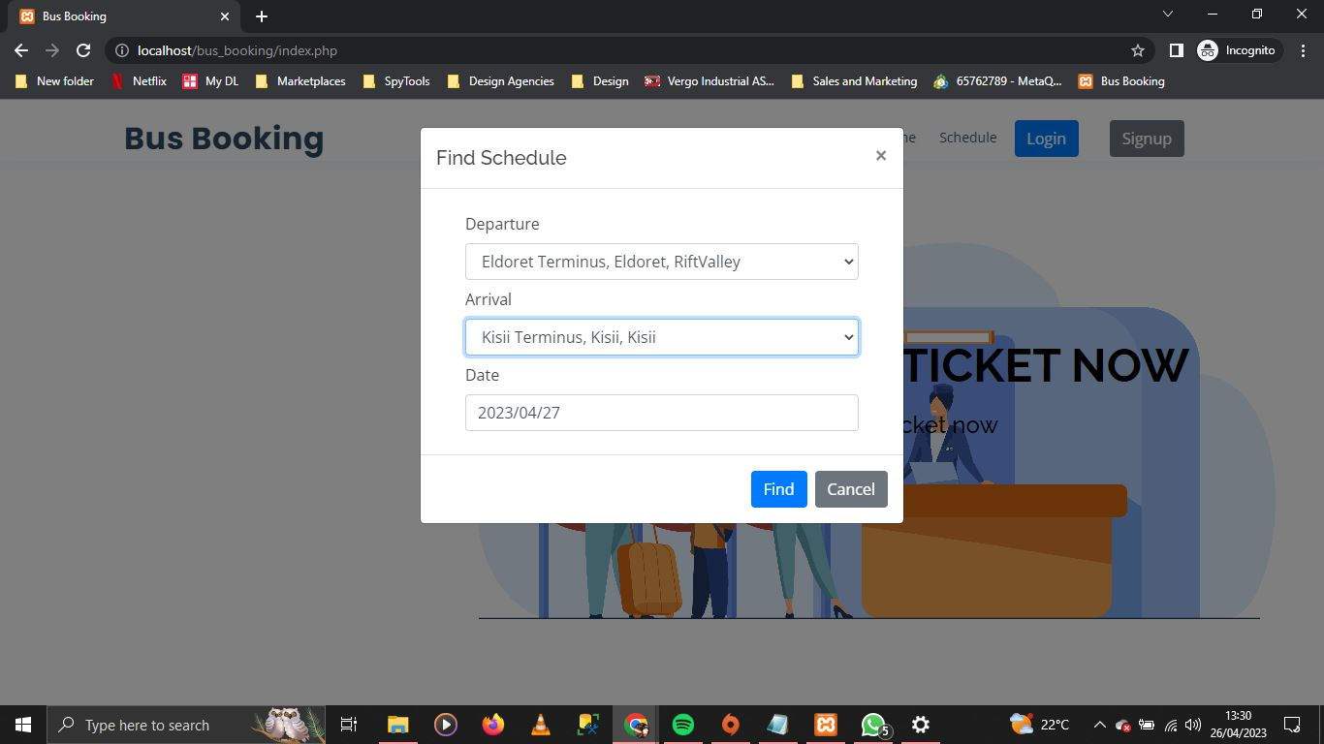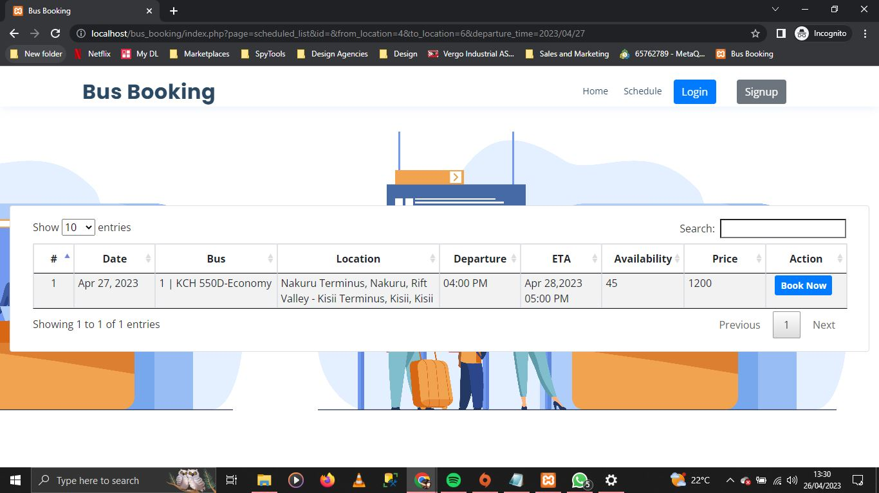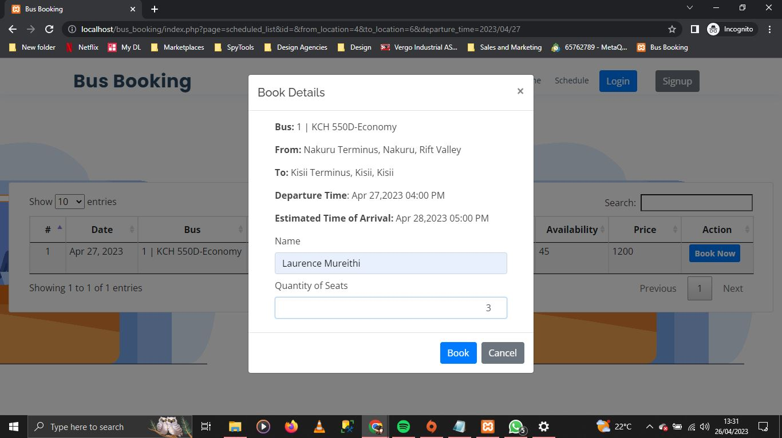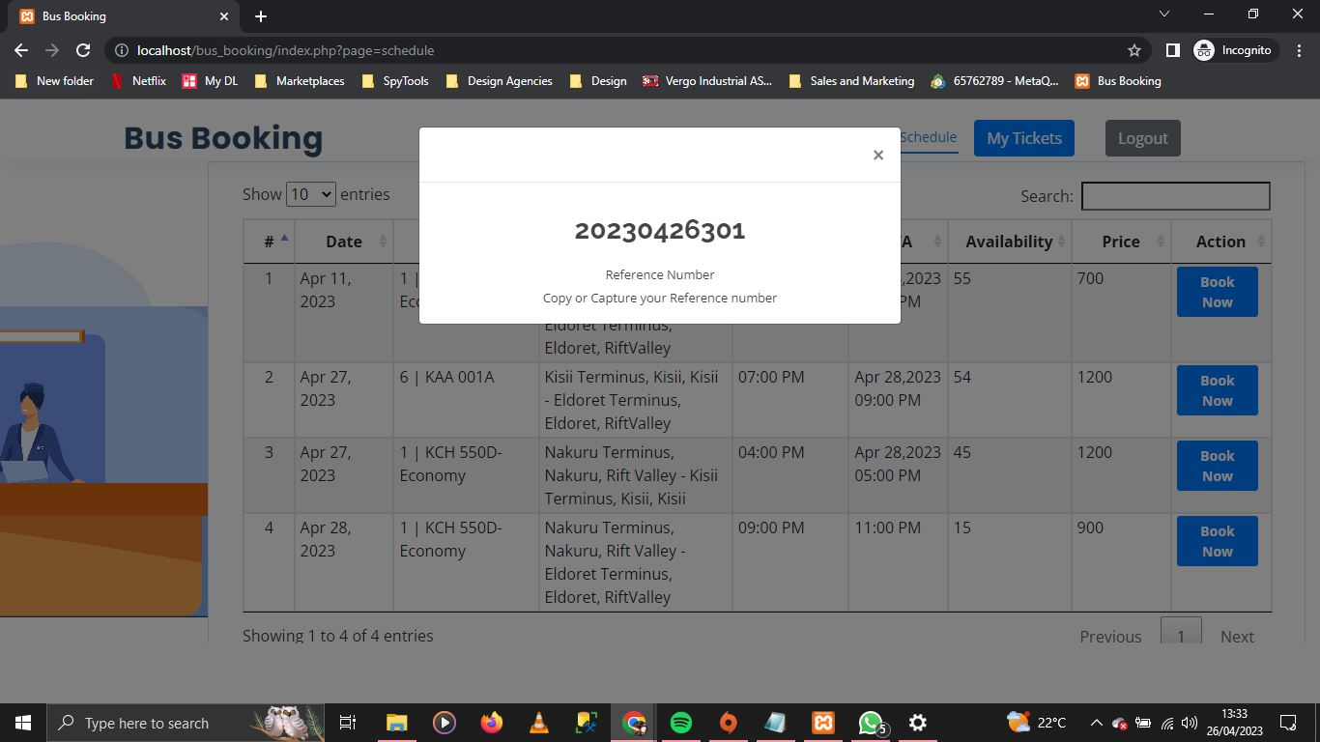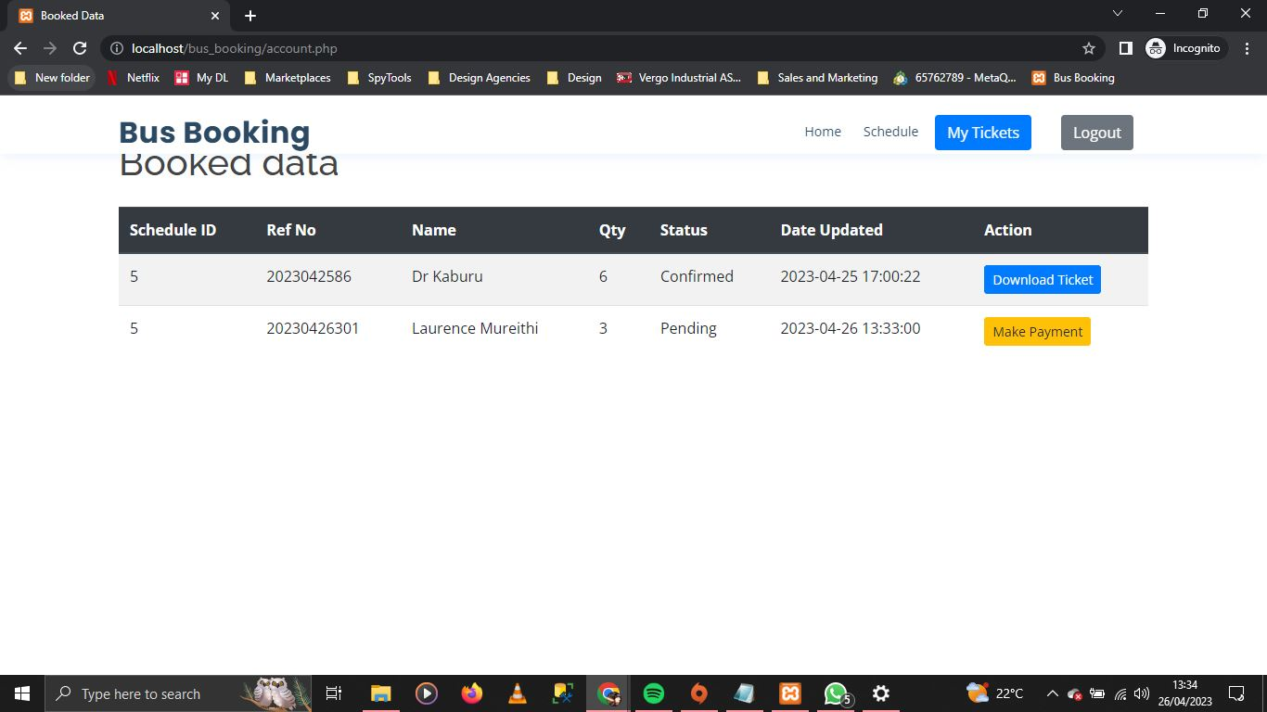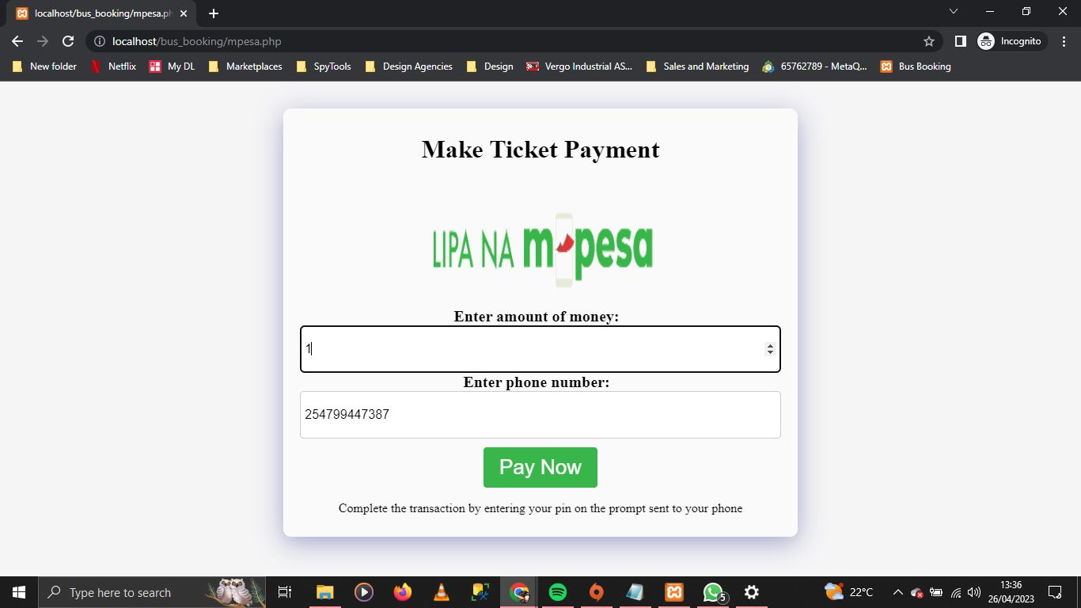

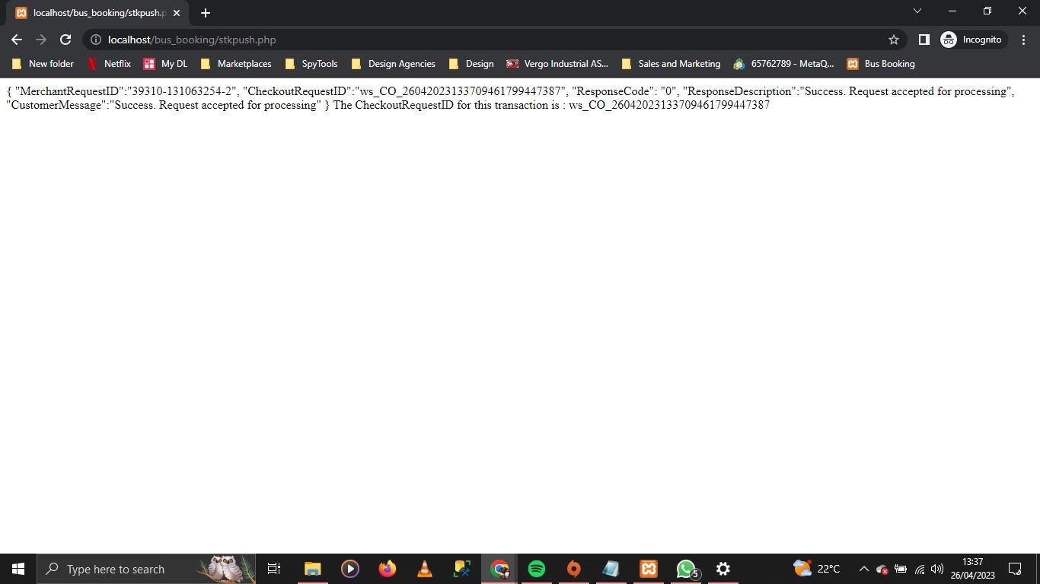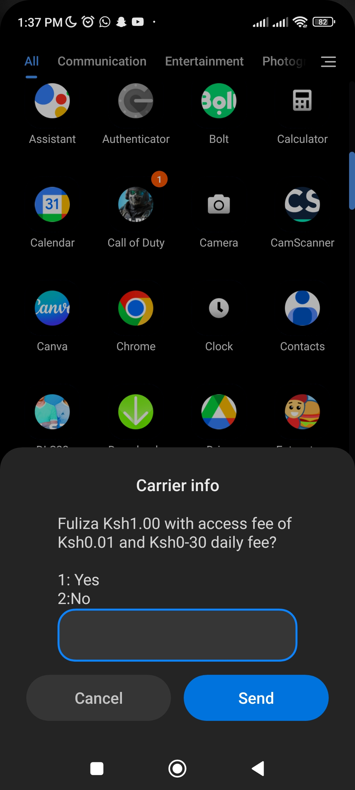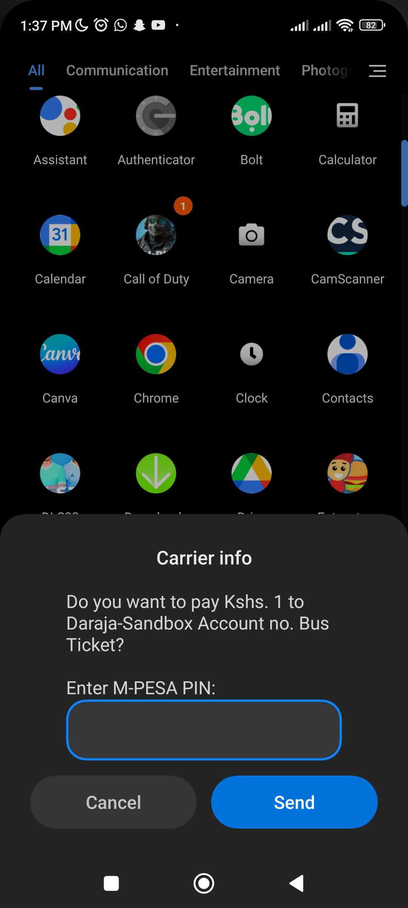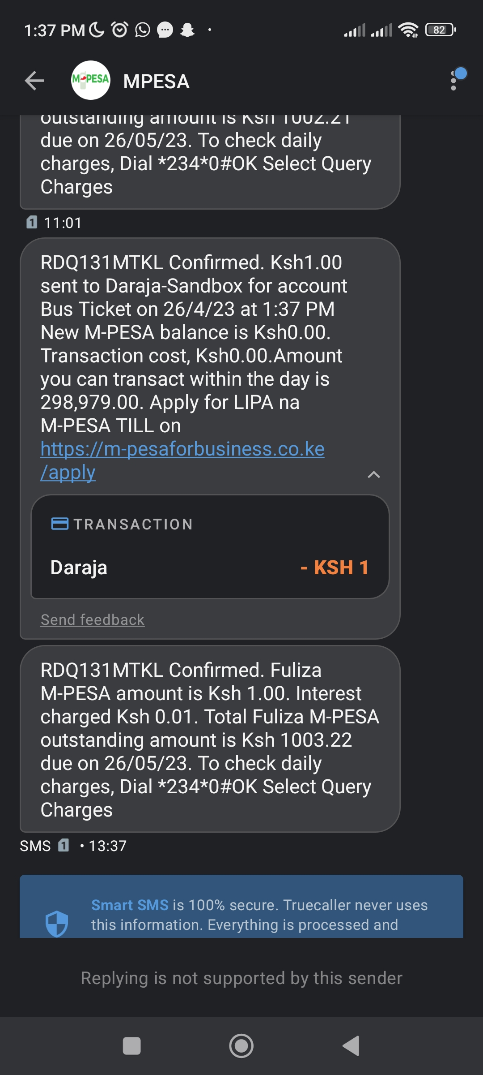

ACCEPTANCE TESTING

Prior to system deployment, acceptance testing will allow both customers and administrators to validate system operation and usability. Users will put the system through its paces by interacting with the database, using network communications, or engaging with other hardware or applications. Instead of synthetic test data, the system is tested with data contributed by end users. Because real data exercises the system in different ways than test data, acceptance testing reveals faults and omissions in the system requirement description. It also reveals requirements issues, such as when the system's facilities do not truly fulfill the needs of the user or when the system's performance is inadequate. The testing process is repeated until the system developer and client agree that the Online Bus Ticketing web portal meets the system requirement.

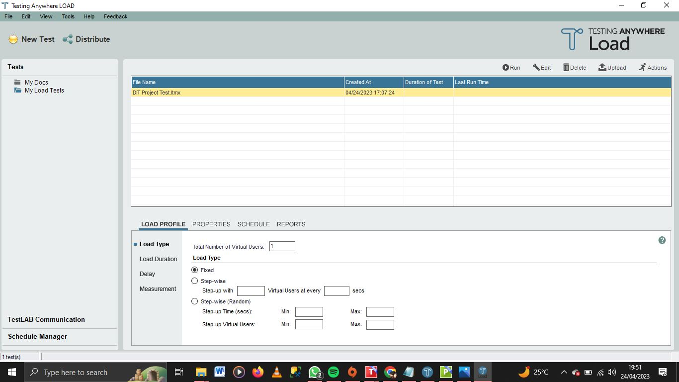

## 4.4 CONCLUSIONS

After examining the various facts of software development, there can be no doubt that the proposed ticketing system solution’s features and capabilities are influential to the Sacco’s business operations. The organizational staff members felt much more involved, engaged and in line with the business. The resources put into this project proved to respond to their needs which reflected as well with the customers.

Based on these conclusions, practitioners should consider the use of real-world solving paradigm solutions to drive a much stronger and efficient form of business. The results indicate that modern businesses show competitiveness and value for business with the integration of systems technology.

However, there is clearly future work to be done on exploring the scalability of the system and additional features that can be integrated into the system for better functionality.

Hopefully this research contributed to an understanding of the need of implementing technology in business operations and that its findings and recommendations can serve as a basis for future research projects.

## 4.5 LIMITATIONS

The proposed system will include a login. This will have (2) levels of access. The first will be the administrator of the system and the client for the second level access. The authorized users will have a unique username and password with a range of 5 – 12 characters long and case sensitive. The user will be allowed (3) consecutive times of entering an invalid username or password combination.

The funding for this project was sufficient enough to develop a working ticketing management system. However, the system could implement more features such as email and message sending, alert or warning notifications of data status instead of manual checking.

Attracting a large number of customers is suitable for any business. However, in consideration of the Wamasaa Investment Sacco as an entity, a ticketing system can attract many customers with issues. This becomes a problem due to the limited resources of a small business for instance; the number of computers within the Sacco.

This is not much of a limitation as something to be aware of. When integrating a new system to business operations, customers and clients will need time to acclimate to the changes. There may be hang ups and snags that are natural with a new system,

## 4.6 RECOMMENDATIONS

Since the effectiveness of systems in businesses has been proven, business should consider incorporating technology-based solutions in their business to maintain quality ticket booking services.

Implementation of the Ticketing Management System as an inquiry based strategy in service should be encouraged by administrators and embraced by members in an effort to continually improve business operations.

Developers are recommended to exploint different types of features that can be integrated in a system to provide efficient services as a solution to a specific problem.

## 4.7 OVERVIEW OF THE CHAPTER

It can be observed that computer applications are very important in every field of human endeavor. Here all the information about customer that made reservation can be gotten by just clicking a button with this new system, some of the difficulties encountered with the manual system are overcome. It will also reduce the workload of the staff, reduce the time taken foor making reservation at the bus terminal and also increase efficiency. The application also has the ability to update records and give a general tracking in the audit trail.

This project as a whole, will give a new way in bus reservation and ticketing processes. The automation and management of seats will be done online.

## 4.8 REFERENCES

Wamuyu, P.K. and Maharaj, M.S., 2011. Factors influencing successful use of mobile technologies to facilitate E-Commerce in small enterprises: The case of Kenya.

Paul, K.M., 2012. Impact of user perceived web quality of service and non quality of service factors on adoption of e-services in Kenya: case study b2c ecommerce

(Doctoral dissertation, University of Nairobi).

Rais, A.A., 2016. Interface-based software integration. Journal of Systems Integration, 7(3), p.79.

Payne, T.H., 2000. Computer decision support systems. Chest, 118(2), pp.47S-52S.

Mbogo, M., 2010. The impact of mobile payments on the success and growth of micro-business: The case of M-Pesa in Kenya. Journal of Language, Technology & Entrepreneurship in Africa, 2(1), pp.182-203.

Innovative ticketing systems for public transport, Policy Advice Notes, CIVITAS (2010), <http://www.civitas.eu/sites/default/files/Results%20and%20Publications/CIVITAS_II_Policy_Advice_Notes_10_Ticketing.pdf>(date of access: May 22, 2014)

Haneberg, D.: Electronic ticketing: risks in e-commerce applications. In: Walfens, P., Walther-Klaus, E. (eds.) Digital Excellence, University Meets Economy, pp. 55–66. Springer, Heidelberg (2008)

Mut-Puigserver, et al.: A Survey of Electronic Ticketing Applied to Transport (2012), <http://www.academia.edu/6150844/A_Survey_of_Electronic_Ticketing_Applied_to_Transport>(date of access: May 24, 2014)

Mezghani, M.: Study on electronic ticketing in public transport, Final Report, European Metropolitan Transport Authorities (EMTA), pp. 30–31, (2008), <http://www.emta.com/IMG/pdf/EMTA-Ticketing.pdf>(date of access: May 24, 2014)

Atlas public transport ticketing system in Riga, Policy Learning in information technologies for public transport enhancement, POLITE, INTERREG IVC, <http://www.polite-project.eu/images/good_practices/payment_systems/atlas_public_transport_ticketing_system_in_riga.pdf>(date of access: May 27, 2014)

Sulaiman, A., Ng, J. and Mohezar, S., 2008. E-ticketing as a new way of buying tickets: Malaysian perceptions. *Journal of Social Sciences*, *17*(2), pp.149-157.

Lee, C. and Wan, G., 2010. Including subjective norm and technology trust in the technology acceptance model: a case of e-ticketing in China. *ACM SIGMIS Database: The DATABASE for Advances in Information Systems*, *41*(4), pp.40-51.

Ashour, L.M., Magatef, S.G. and Alzaghal, Q.K., 2023. The Impact of E-Ticketing on Behavioral Intention to Use and the Moderating Role of Information and Communication Technology Tools. In *International Conference on Business and Technology* (pp. 483-507). Springer, Cham.

Robertson, G., Zhang, S. and Bogus, S.M., 2022. Challenges of Implementing E-Ticketing for Rural Transportation Construction Projects. In *Construction Research Congress 2022* (pp. 453-462).

Karami, M., 2006. Factors influencing adoption of online ticketing.

Nikhashemi, S.R., Haque, A., Yasmin, F. and Khatib, A., 2012. Service Quality and Consumer Purchasing Intention Toward Online Ticketing: An Empirical Study in Iran. In *International Conference on Economics, Business Innovation IPEDR* (Vol. 38, pp. 150-154).

Sandiwarno, S., 2018. Design Model Of Bus Ticketing By Seating At Pt. Xyz. *International Journal Of Computer Science And Mobile Computing A Monthly Journal Of Computer Science And Information Technology*, pp.1-7.

Muthumbi, A.W., 2016. Online bus ticketing system.

Lubanga, J.M., Gakobo, T., Ochieng, I. and Kimando, L.N., 2017. Factors influencing adoption of e-payment system in Kenyan public transport: a case of matatu plying Nairobi-Kitengela route. *International Academic Journal of Human Resource and Business Administration*, *2*(4), pp.27-48.

Busingye Godfrey, M., 2011. Design and Implementation of Sms Bus Booking System to Increase Efficiency and Effectiveness of Bus Services: A Case Study of Link Bus Company.

mrana, A.Y., 2014. Design and Implementation of an Online Bus Ticketing System (A case study of Sokoto State Transport Authority).

## APPENDICES

Instruments

Instrument 1: Sublime Text 3.

Instrument 2: Google Chrome.

Instrument 3: Microsoft Office.

Instrument 4: Test Anywhere (Client and Load).

Letters of introduction

Budget

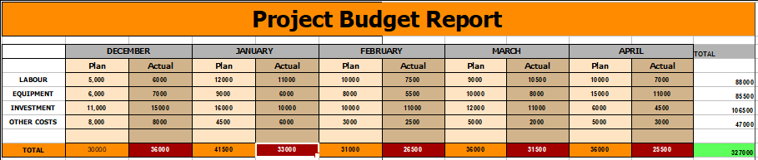

Work plan

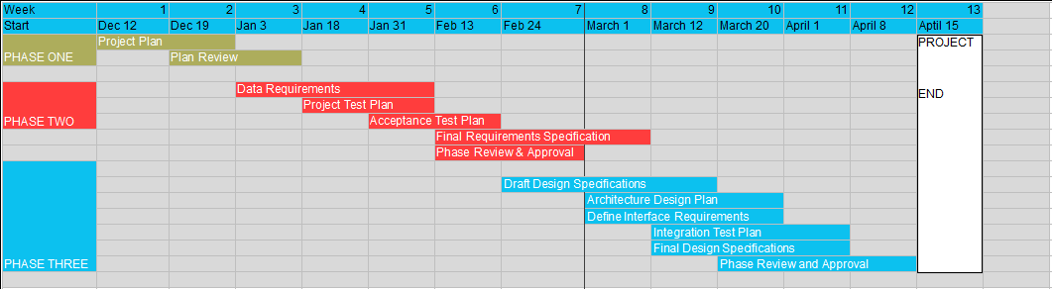

Figures

Figure 1: Age of Respondents (Statistical Data)

Figure 2: Age of Respondents (Pie Chart)

Figure 3: Age of Respondents (Horizontal Bar Graph)

Figure 4: Purpose at Bus Terminus (Statistical Data)

Figure 5: Purpose at Bus Terminus (Horizontal Bar Graph)

Figure 6: Purpose at Bus Terminus (Pie Chart)

Figure 7: Analysis Report (Statistical Data)

Figure 8: Analysis Report (Horizontal Bar Graph)

Figure 9: Questionnaire Template

Figure10: Questionnaire Statistical Data

Figure 11: Logical Design

Figure 12: Physical Design

Figure 13: Client-Server Architecture

Figure 14: Microservices Architecture

Figure 15: Object Oriented Design

Figure 16: Use Case Diagram

Figure 17: Data Flow Diagram